**Angular 2 to 9**

**A. Setup**

1. Angular is a framework which allows you to create reactive, single page applications.

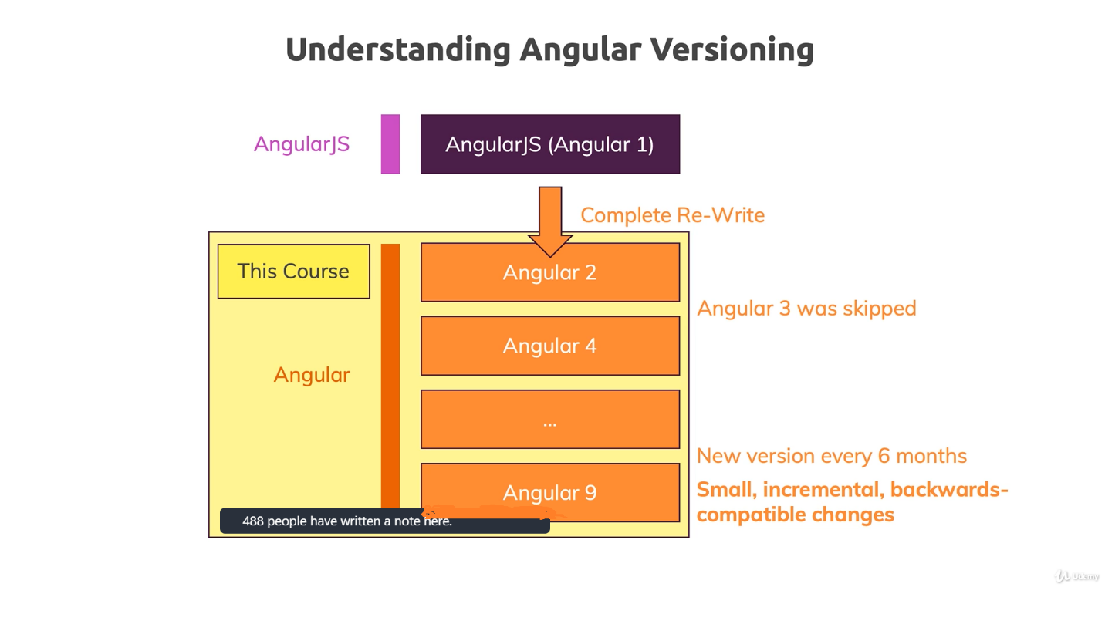

1. Commands for angular setup:
   1. npm install -g @angular/cli@latest
   2. ng new my-first-app
   3. cd my-first-app
   4. ng serve
2. TypeScript:

Typescript, really is just a superset of JavaScript.

It offers more features than vanilla JavaScript, like classes, interfaces and, very important, which gives it the name, types; strong typing. So, you define in Typescript if a certain variable is a number, a string or something else.

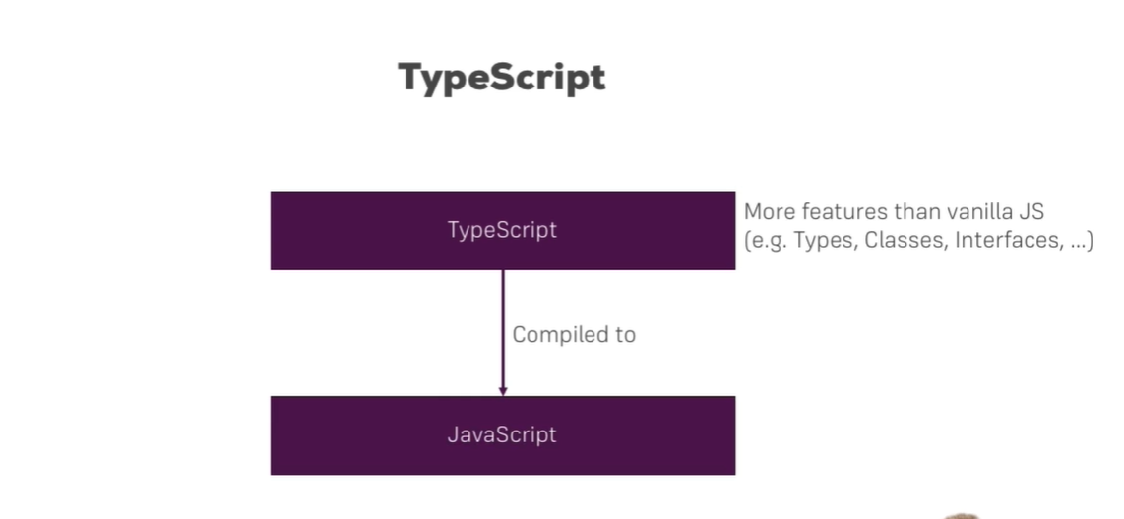

1. Can use Bootstrap for styling
   1. npm install –save bootstrap@3
   2. change angular.json to setup bootstrap
   3. add “node_modules/bootstrap/dist/css/bootstrap.min.css" in styles array.
2. How an Angular App gets Loaded and Started
   1. Ng serve rebuild our project and add javascript bundle and import in index.html file so before in raw file we don’t have bundle but after build it import automatically.

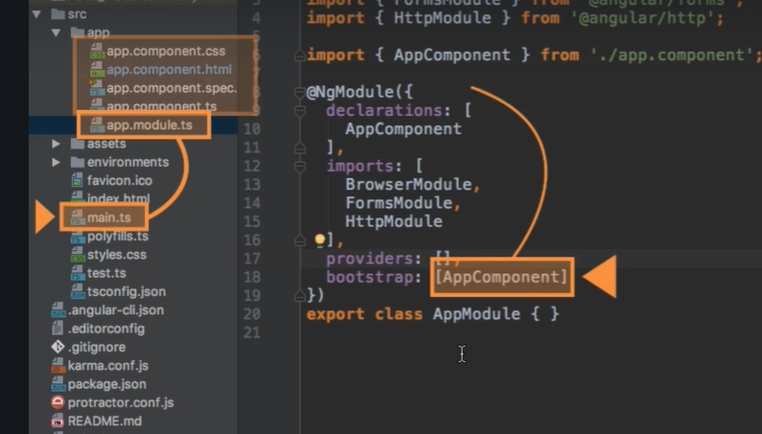

1. Component
   1. ng g c component-name or ng generate component component-name
   2. ng g c component-name --skipTests=true (for excluding testing file)
   3. component selector can be used as three way which are directly as tags or attribute or class.

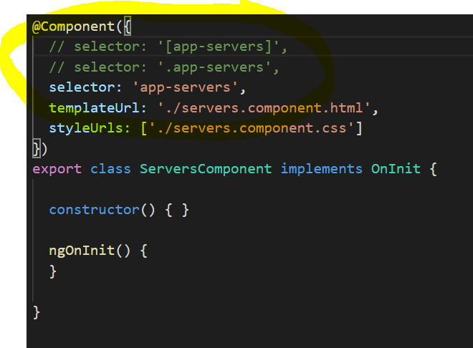 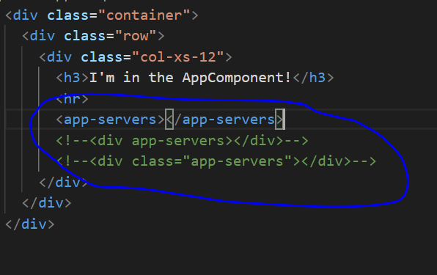

1. Data binding
   1. data binding is communication. Communication between your TypeScript code of your component, your business logic and the template.
   2. Types of data binding
      1. String Interpolation – it converts all data in string and show in html file.
      2. Property Binding – use to bind data in property or attribute of html tags.
      3. Event Binding – use to bind function for html tag event like click, hover etc.
      4. Two-way Binding – combine property and event binding using [(ngmodel)].
   3. Property binding can be used as string interpolation using [innerHtml] property.

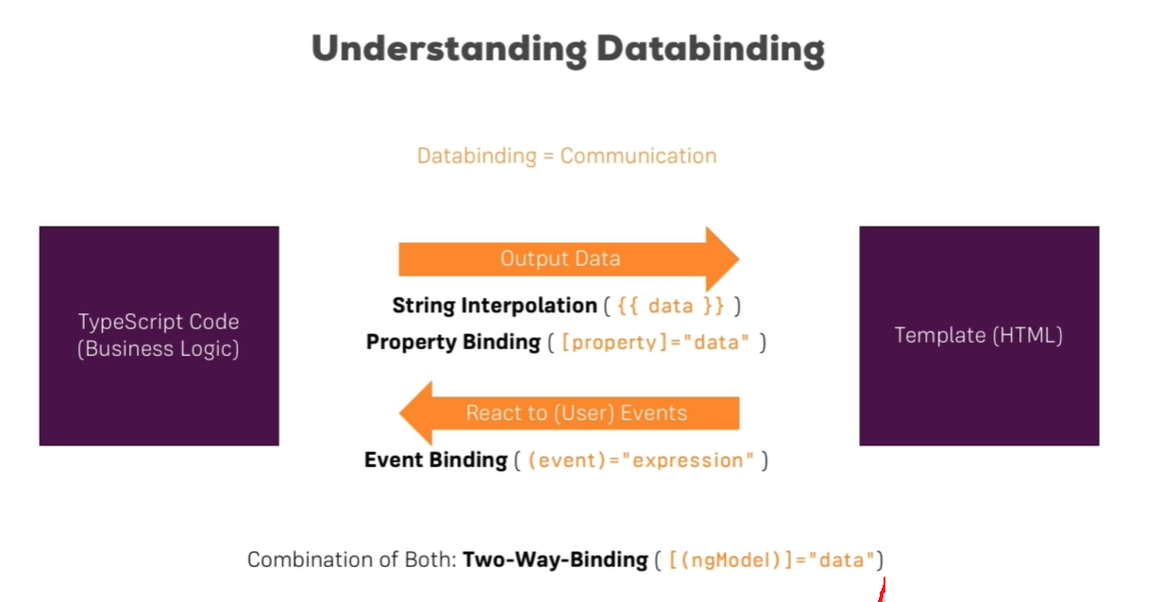

1. Directives
   1. Directives are instructions in the DOM.
   2. components are kind of such instructions in the DOM. Once we place the selector of our component somewhere in our templates, at this point of time we're instructing Angular to add the content of our component template and the business logic in our TypeScript code in this place where we use the selector.
   3. Types of directives
      1. Components—directives with a template
      2. Structural directives – change the DOM layout by adding and removing DOM elements. Like ngIf, ngFor
      3. Attribute directives – change the appearance or behavior of an element, component, or another directive. Like ngStyle and ngClass

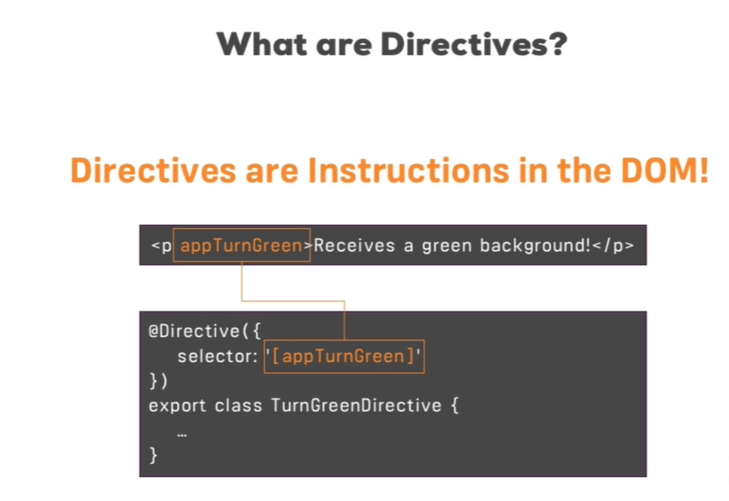

1. Binding to Custom Properties (Component interaction)
   1. @Input() – share data from parent to child using property binding
   2. @Output() – perform action on child and trigger event in parent using event binding

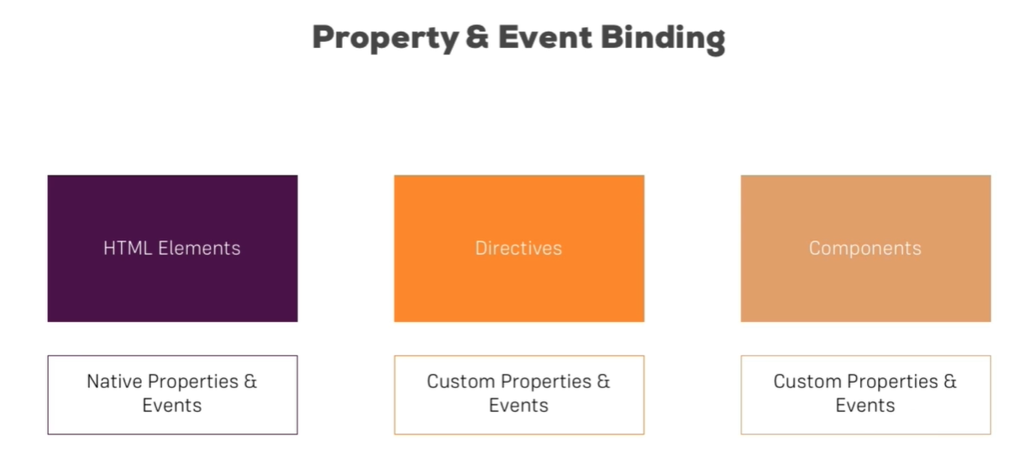

1. View Encapsulation
   1. In Angular, component CSS styles are encapsulated into the component's view and don't affect the rest of the application.
   2. To control how this encapsulation happens on a per component basis, you can set the view encapsulation mode in the component metadata. Choose from the following modes:
      1. **ShadowDom** view encapsulation uses the browser's native shadow DOM implementation to attach a shadow DOM to the component's host element, and then puts the component view inside that shadow DOM.
      2. **Emulated** view encapsulation (the default) emulates the behavior of shadow DOM by preprocessing (and renaming) the CSS code to effectively scope the CSS to the component's view.
      3. **None** means that Angular does no view encapsulation. Angular adds the CSS to the global styles

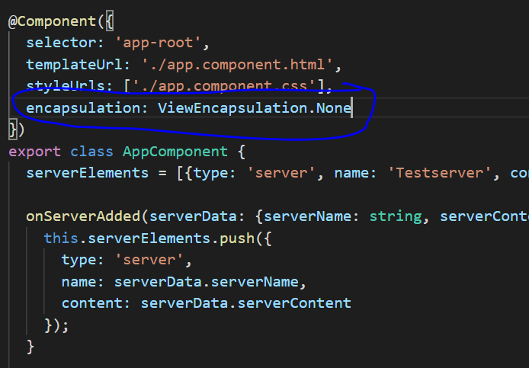

1. Local References in Template
   1. It can be use in template or html not in component.
   2. In place of two-way binding it can be use.

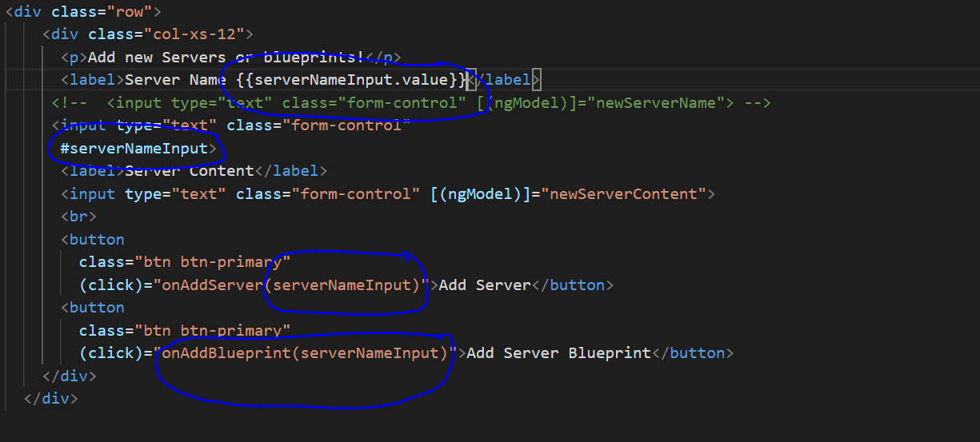

1. @ViewChild() in Angular 8+
   1. add { static: true } as a second argument needs to be applied to ALL usages of @ViewChild() If you plan on accessing the selected element inside of ngOnInit()
   2. In place of two-way binding it can be use.

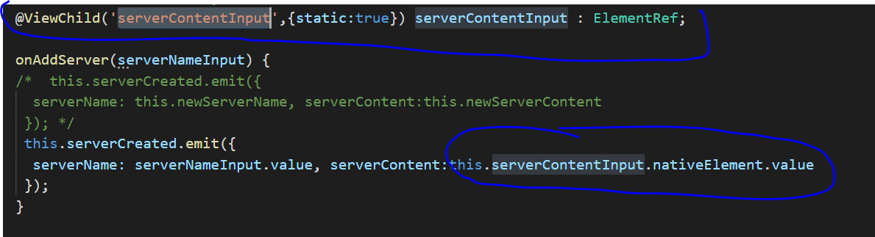

1. Projecting Content into Components with ng-content
   1. In place of @Input() we can use ng-content
   2. You use the <ng-content></ng-content> tag as a placeholder for that dynamic content, then when the template is parsed Angular will replace that placeholder tag with your content.

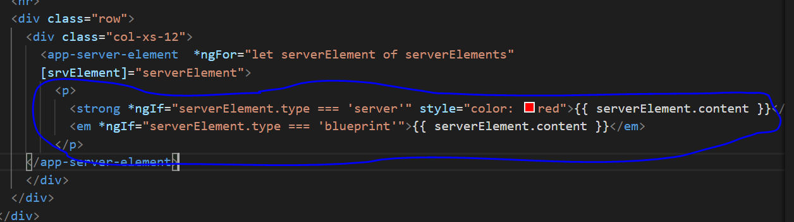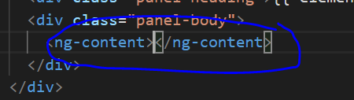

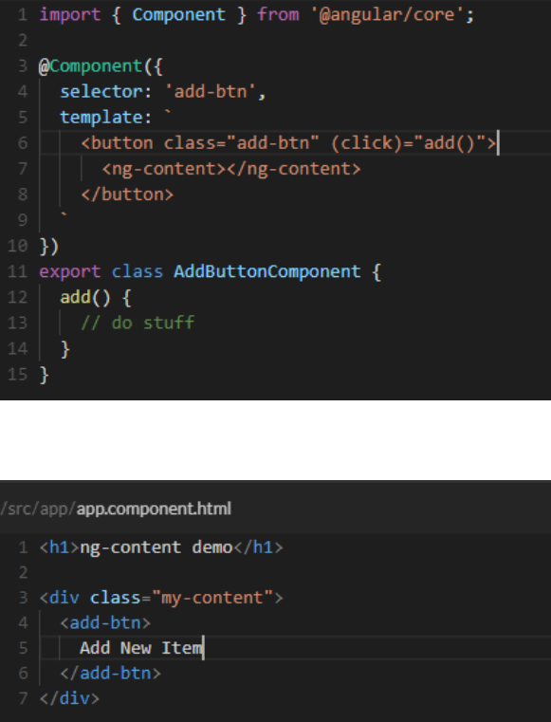

1. Lifecycle
   1. The **ngOnChanges()** method takes an object that maps each changed property name to a **SimpleChange** object holding the current and previous property values. This method only accept argument in lifecycle method.

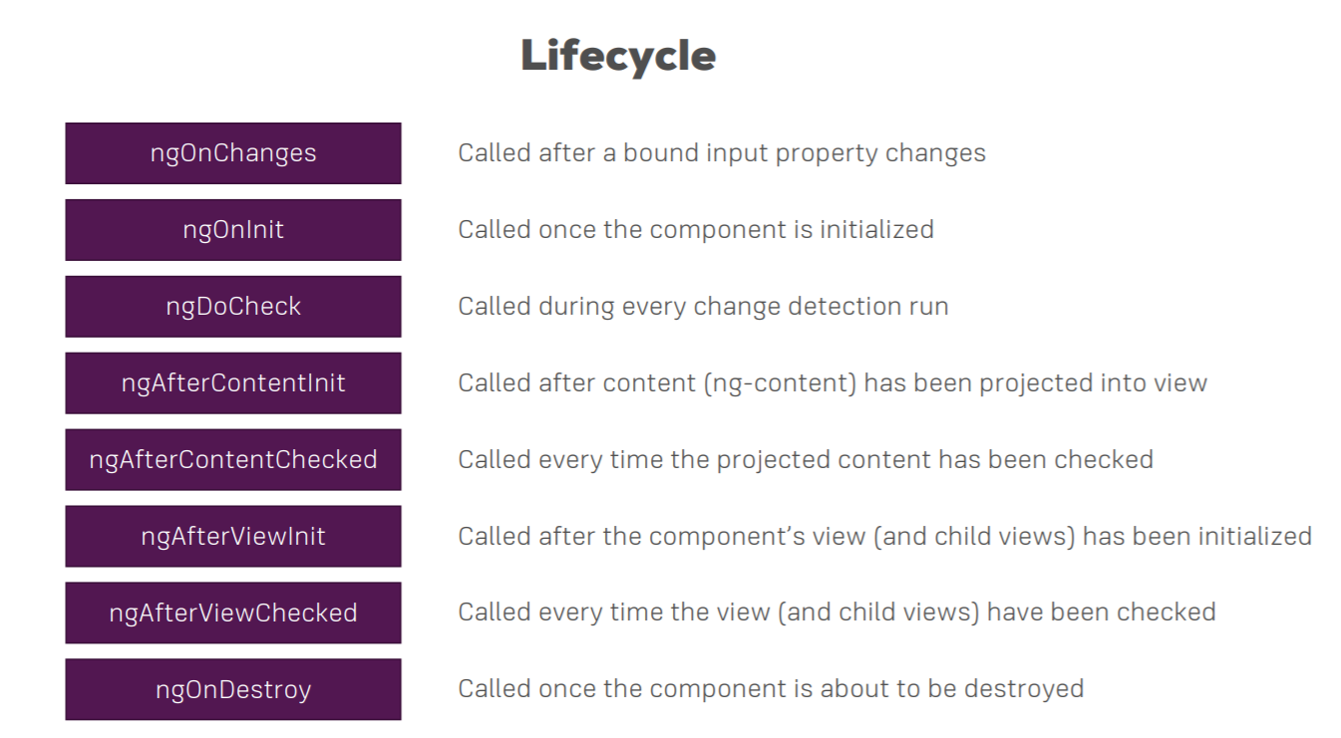

1. Getting Access to ng-content with **@ContentChild** in Angular 8+

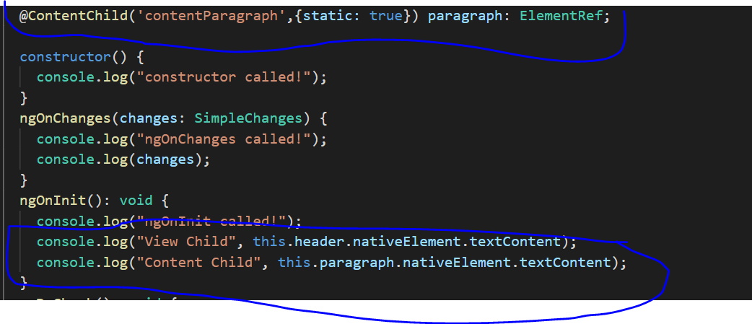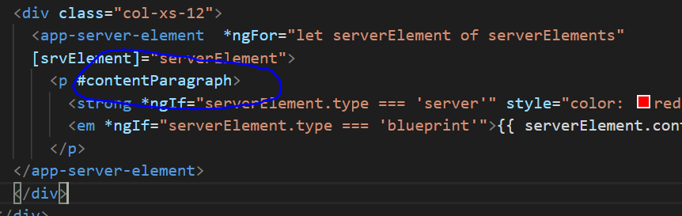

1. Attribute Vs Structure Directives

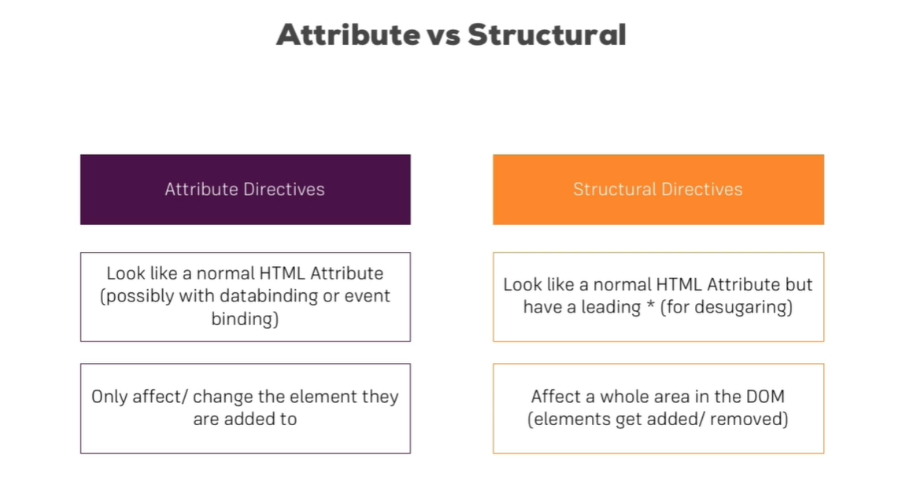

1. Custom Attribute Directive
   1. -> ng g d directive-name
   2. Accept **ElementRef** as argument in constructor and after adding private in front of it become property of that directive.
   3. In selector used bracket because its attribute directive.
   4. Two way to change element: first directly change ElementRef or second way is change using Renderer2( recommended because may get error when we change directly to elementRef ).
   5. we can use the Renderer for any DOM manipulations.

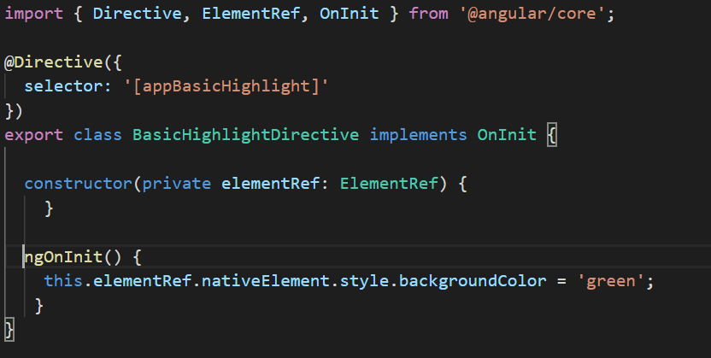

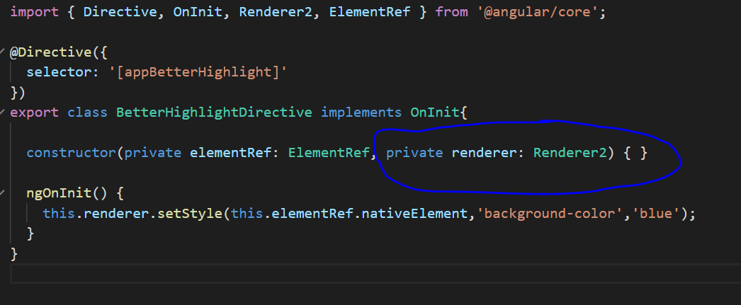

1. Using HostListener to Listen to Host Events
   1. Decorator that declares a DOM event to listen for and provides a handler method to run when that event occurs.
   2. Can be use in custom directive or in component to KeyboardEvent or Mouse Event.

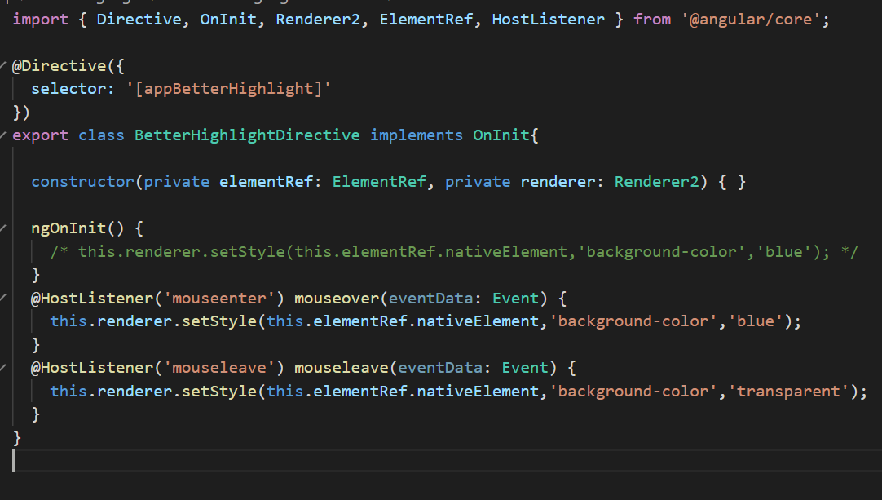

1. Using HostBinding to Bind to Host Properties
   1. Use to bind host properties in custom directive

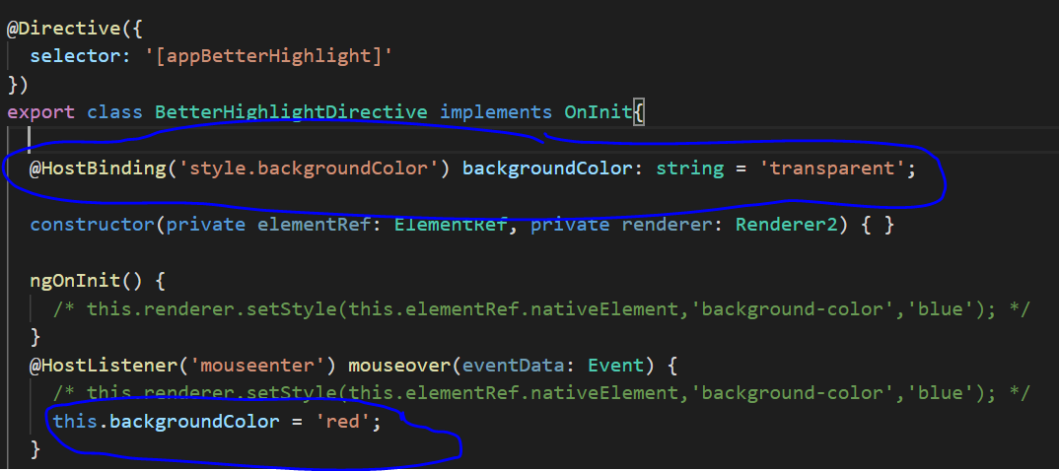

1. Binding to Directive Properties
   1. Binding to directive properties using @Input decorator

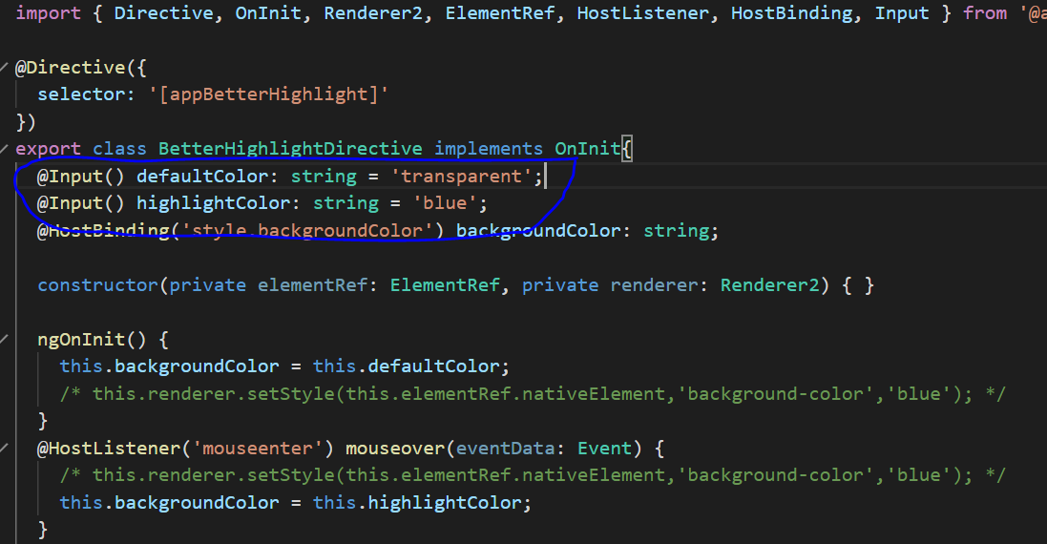 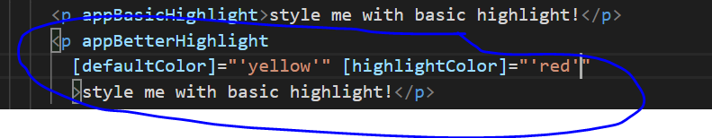

1. Custom Structural Attribute

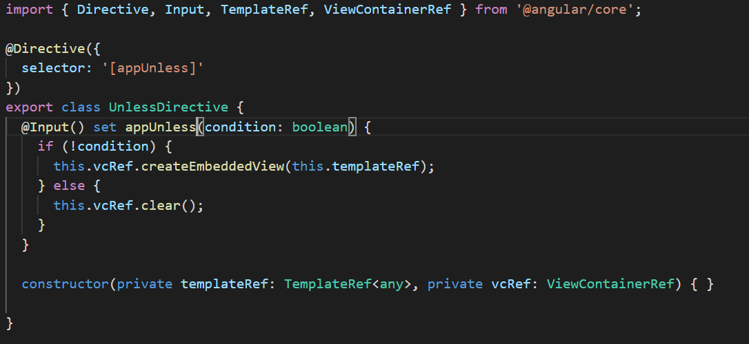

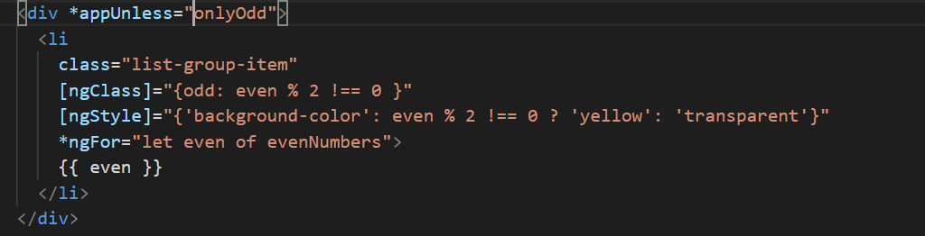

1. ngSwitch directive

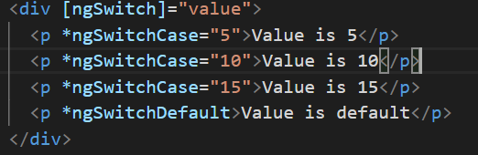

1. Service
   1. a service is basically just another piece in your Angular app, another class you can add which acts as a central repository, as a central business unit you could say, something where you can store, where you can centralize your code in.
   2. -> ng g s service-name
   3. Service can be inject in component level or in module level using providers metadata.
   4. Injecting Services into Services we should have add Injector decorator.
   5. Using Services for Cross-Component Communication through EventEmitter. It can use in best for parent child communication has multiple child level which reduce lot of codes.
   6. Services in Angular 6+, Instead of adding a service class to the providers[] array in AppModule , you can set the following config in @Injectable({ providedIn: ‘root’}).

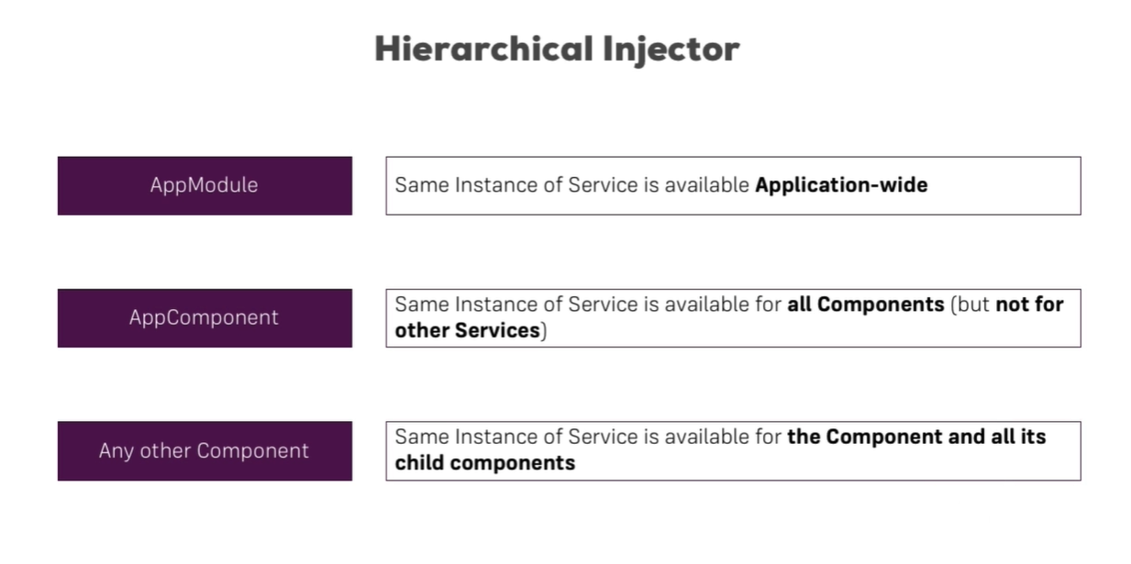

statusUpdated = new EventEmitter<string>();

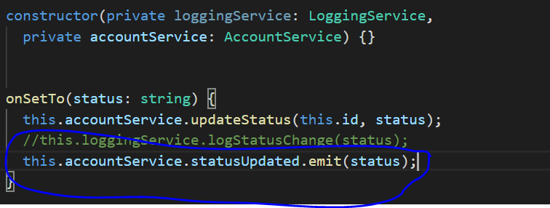 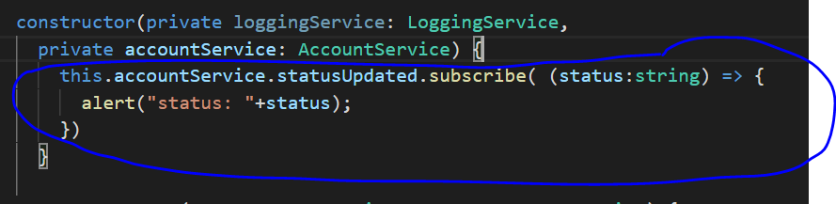

1. Routing
   1. First we have to create **Routes** constant and add path there with respective component
   2. Then import **RouteModule.forRoot(routes)** in AppModule import.
   3. **<router-outlet></router-outlet>** is placeholder where all component template should show.
   4. **routerLink** attribute is used in place of href attribute to prevent <a> tag behavior which reload page and create new request. So if we use routerLink then it will not reload page and use same request that’s difference between href and routerLink attribute.
   5. **routerLinkActive** is added to all routes and then whoever route is active will be shown as active automatically. In bootstrap we use routerLinkActive at parent level not in <a> tag so bootstrap automatically add active class there.
   6. By default first route will be active always so to prevent that we need to use **routerLinkActiveOptions** attribute([routerLinkActiveOptions]="{exact: true}").
   7. **queryParams** attribute is used to pass query in url and **fragment** attribute is used to pass fragment in url.
   8. **Child route** need their own <router-outlet> placeholder to show content.

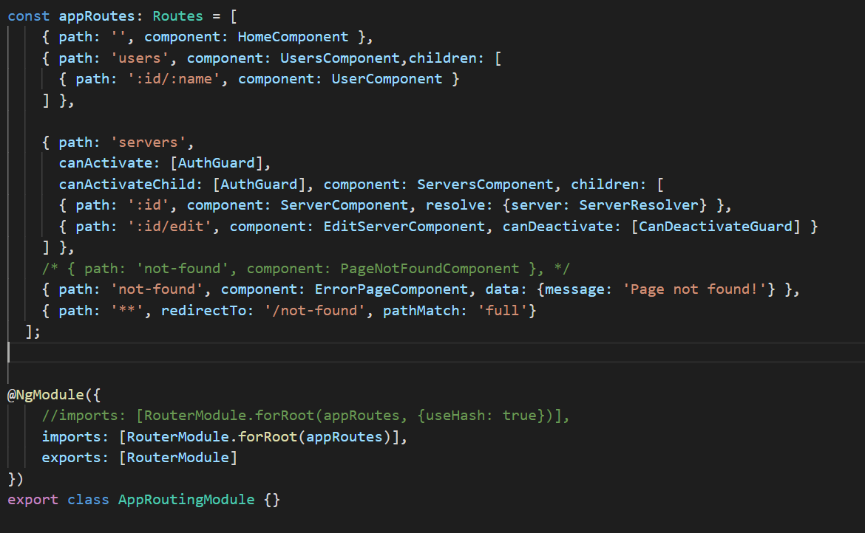

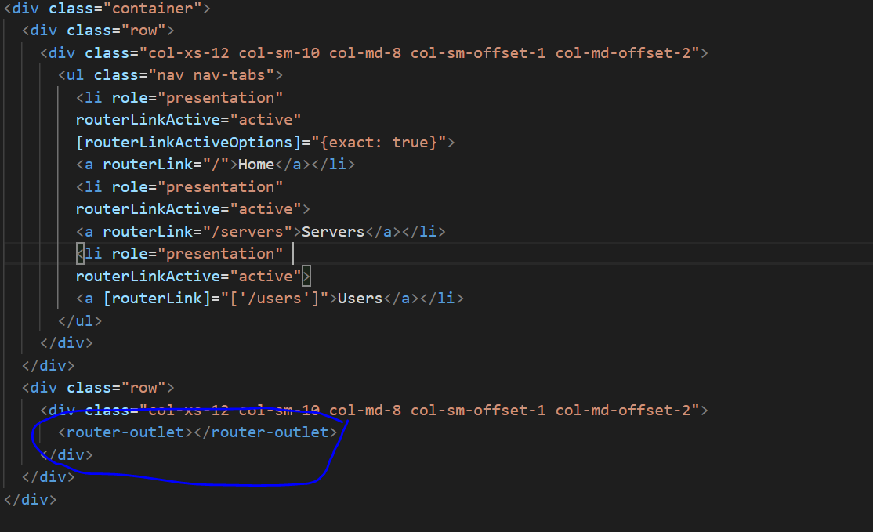

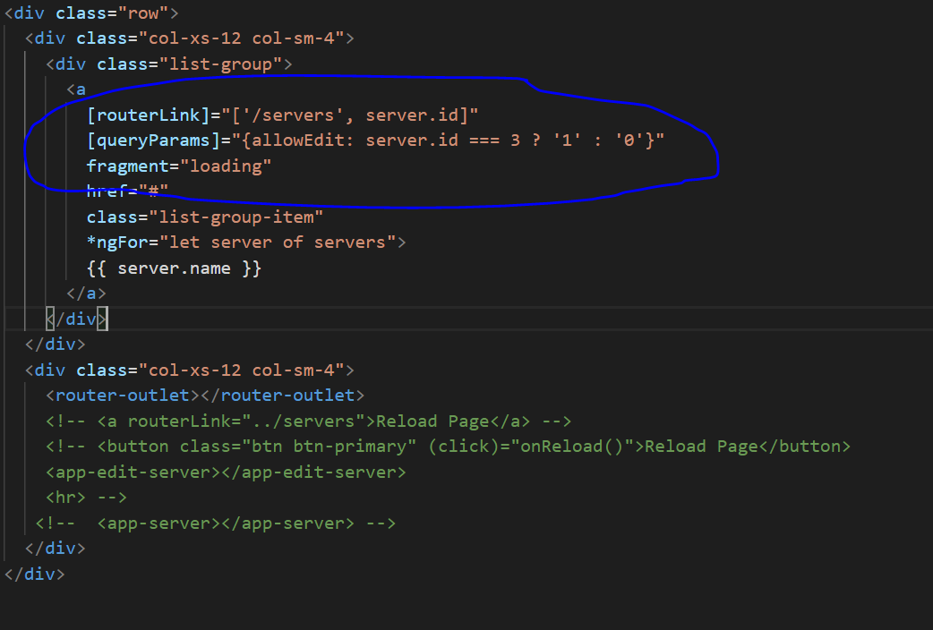

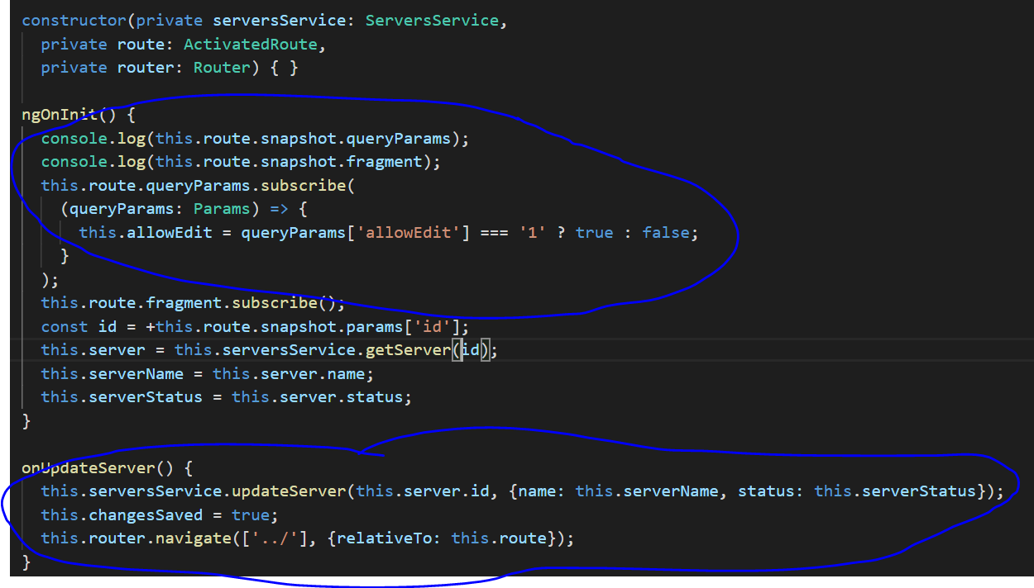

1. An Introduction to **Guard**
   1. So basically functionality, logic, code which is executed before a route is loaded or once you want to leave a route is implemented by **Guard**.
   2. Protecting Routes with **canActivate**, which uses Guards. Just mention Guard in canActivate for that route in route const array. canActivate decide that the route should load or not but **resolver** only fetch dynamic data which we can use later in that component before page loading.
   3. Same way we can protect child route with **canActivateChild**, which also uses Gaurds. Just mention Guard in canActivateChild for that route in route const array.
   4. We can control Navigation with **canDeactivate** which is used when we navigate away from current page.
   5. We can pass Static Data to a Route once our route is loaded, by adding **data** in route const.
   6. We use **resolver** to fetch dynamic data which we can use later in that component. So for this we need to create resolver service add in routing module using resolve in path.
   7. If we want the deployment server to ignore the url before # then we can mention this in app routing module. The deployment server ignore url before # and angular take care the part # in url for that use **{useHash: true}.**

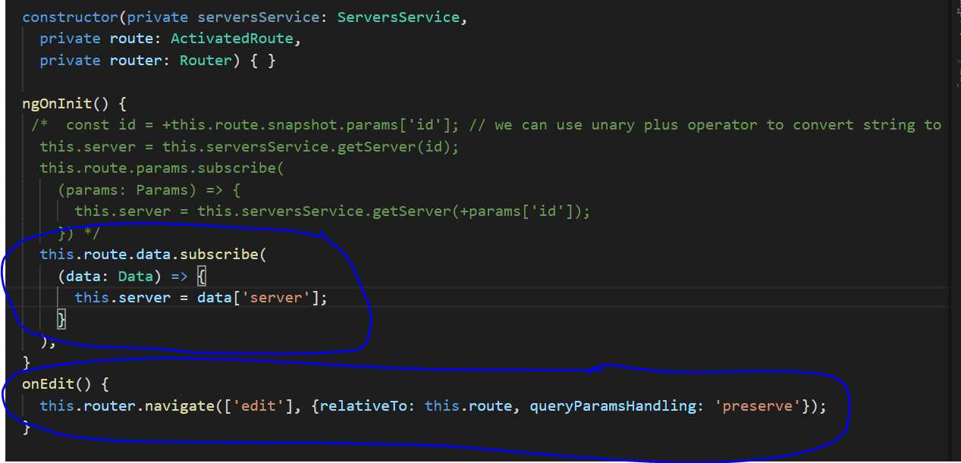

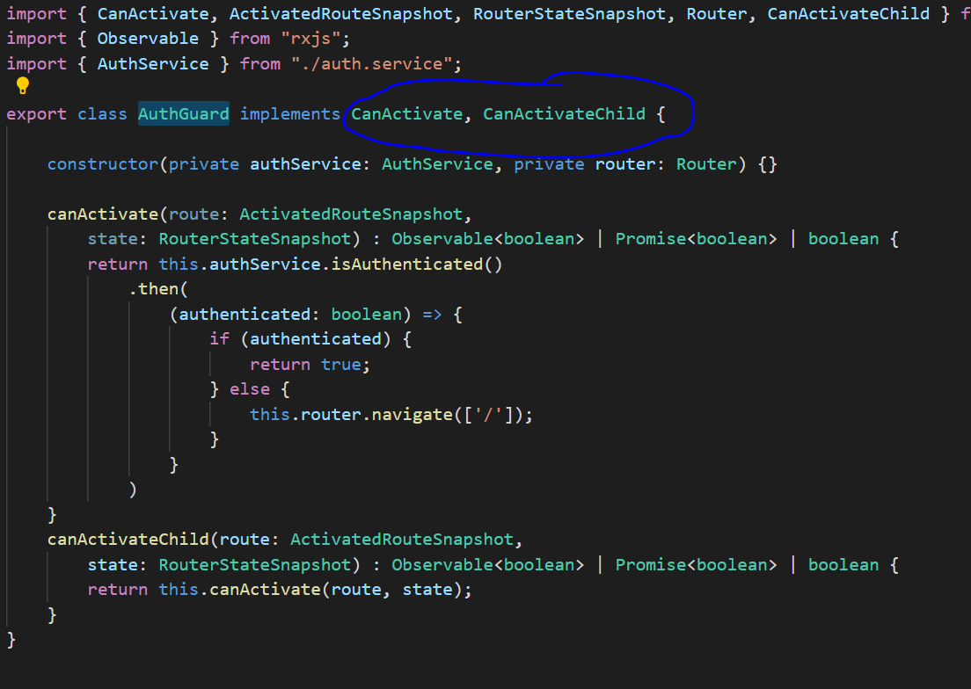

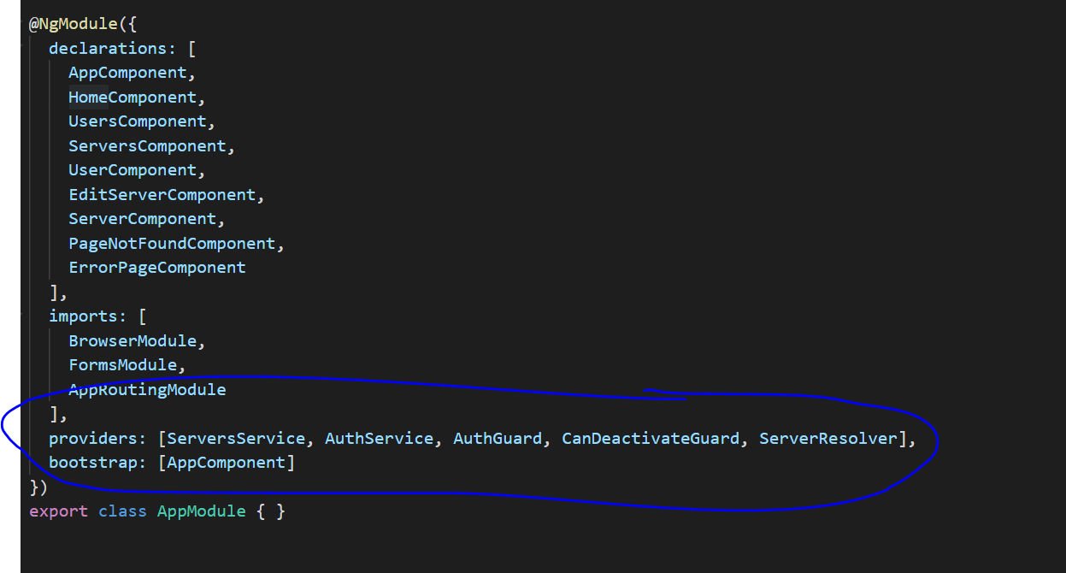

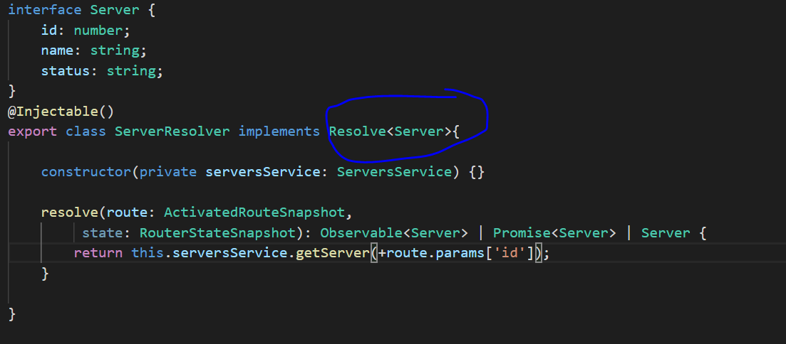

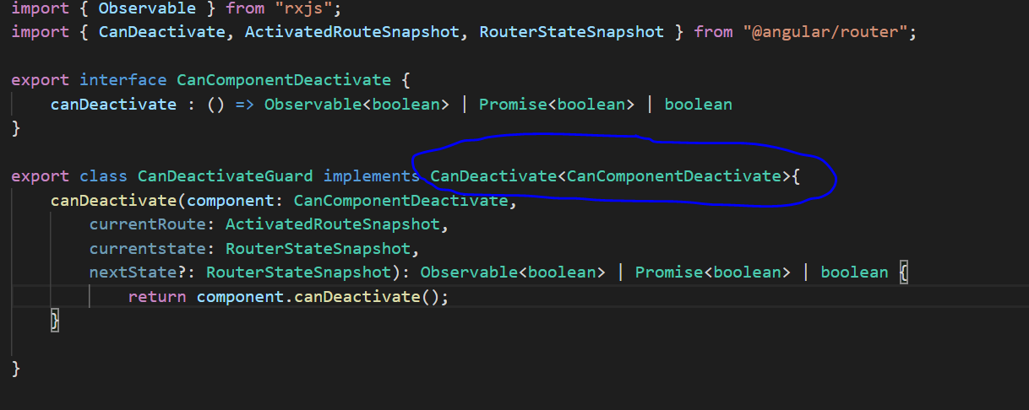

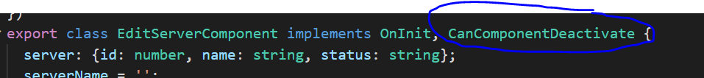

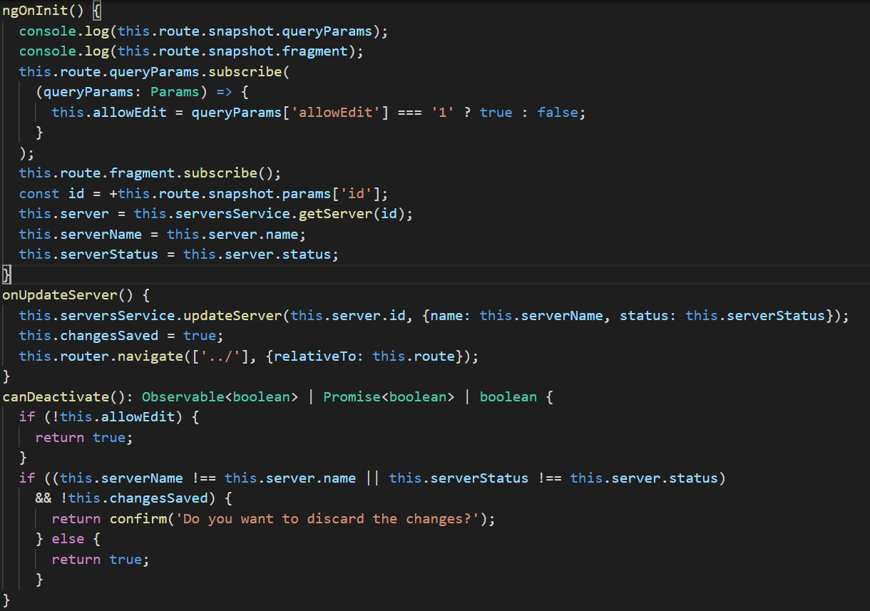

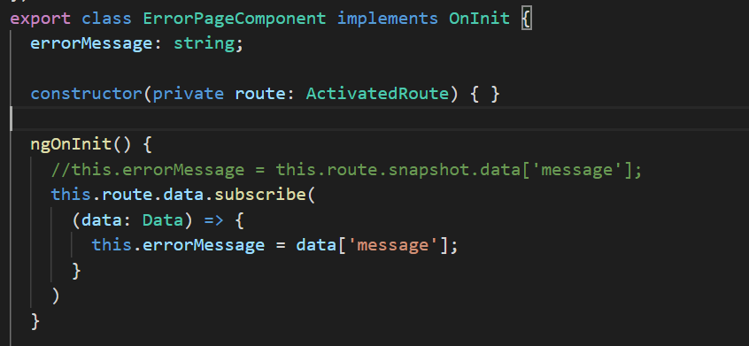

1. Observables
   1. Angular unsubscribe all angular observables like http request.

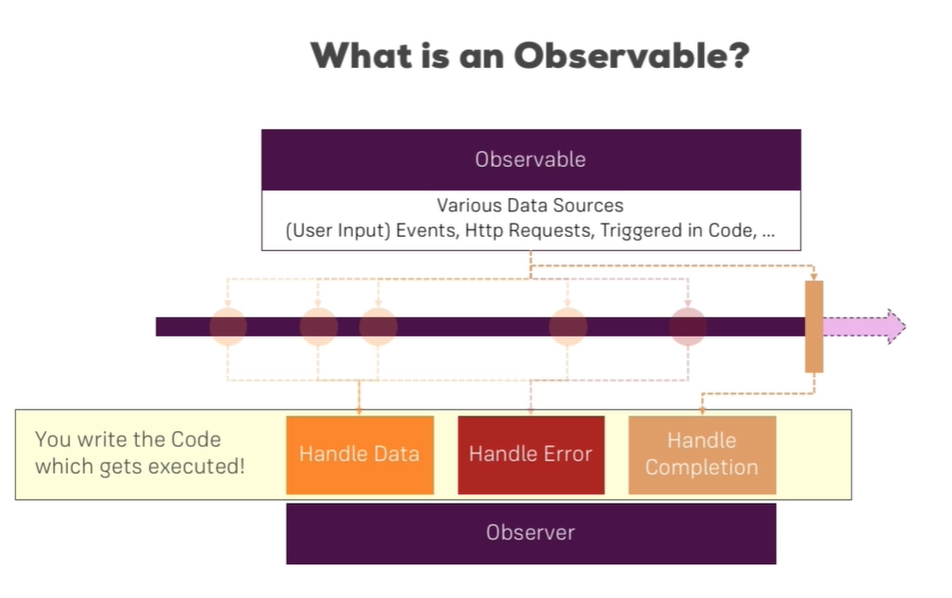

* 1. Interval is predefined observable in rxjs library.

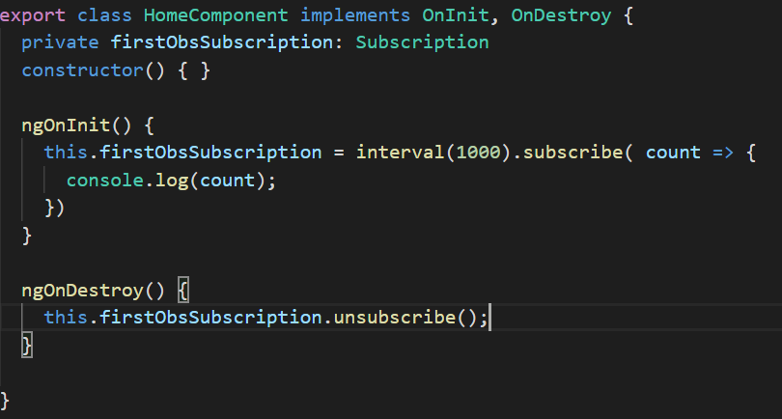

* 1. We can create own Observable from rxjs library.

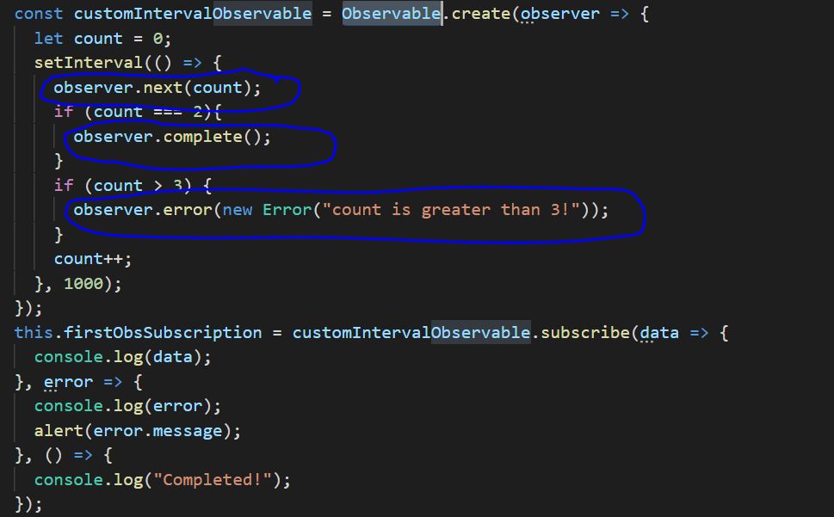

* 1. Operator which we can in observable, which work before we subscribe data.
  2. Every observable has pipe() method where we can use operators like map (to iterate all data), filter( to filter data) etc.

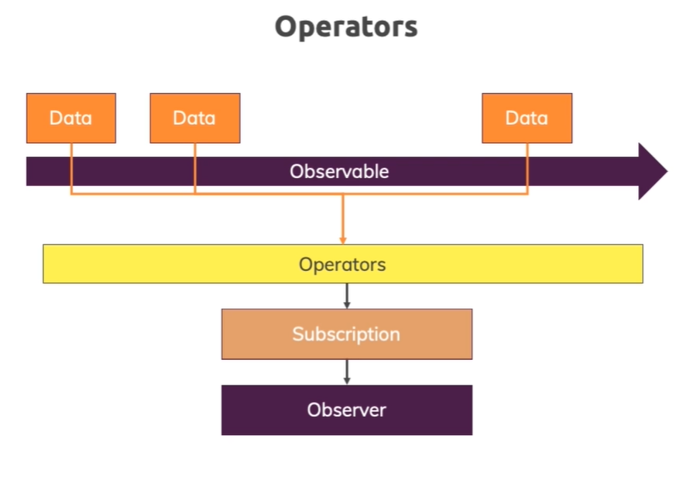

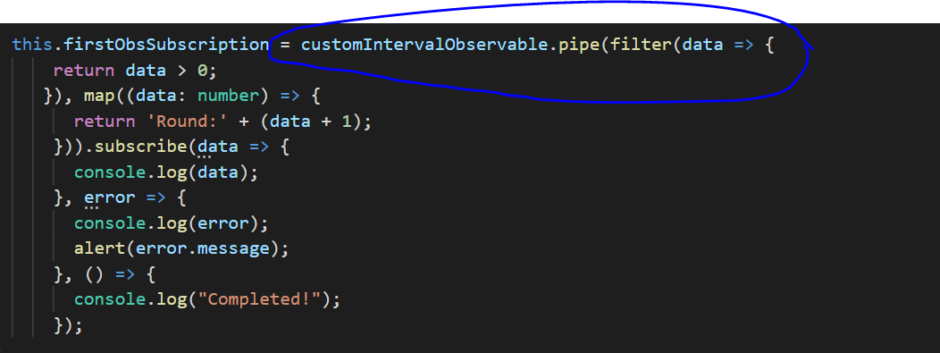

1. Subjects
   1. a **subject** is recommended way. Don't use event emitter, use subjects they are in the end a bit more efficient.
   2. use **subjects** instead of observables.
   3. use **subjects** to communicate across components, through services so through a mechanism where you in the end subscribe to somewhere, like here in the app component.

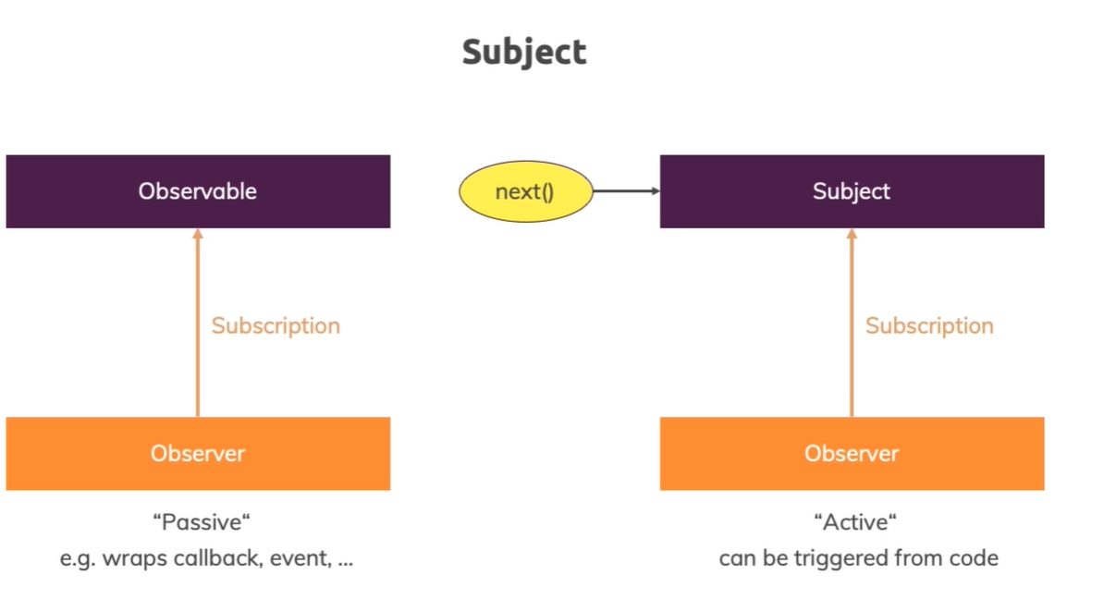

1. Forms
   1. There are two ways to implement form in angular: **Template-Driven** and **Reactive**
   2. In Template-Driven Form, we have access form object in component two ways: first directly pass local reference and second using **@ViewChild().**
   3. In Template-Driven Form, we can use input filed with **no binding**{ <input ngModel name=”email” type=”text”>}, one way binding or **property binding** { <input [ngModel] name=”email”>} and **two-way binding** { <input [(ngModel)] name=”email”>}

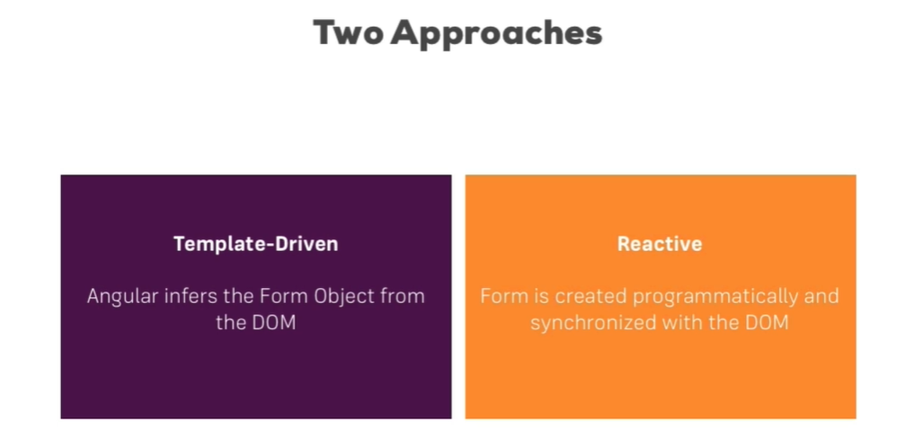

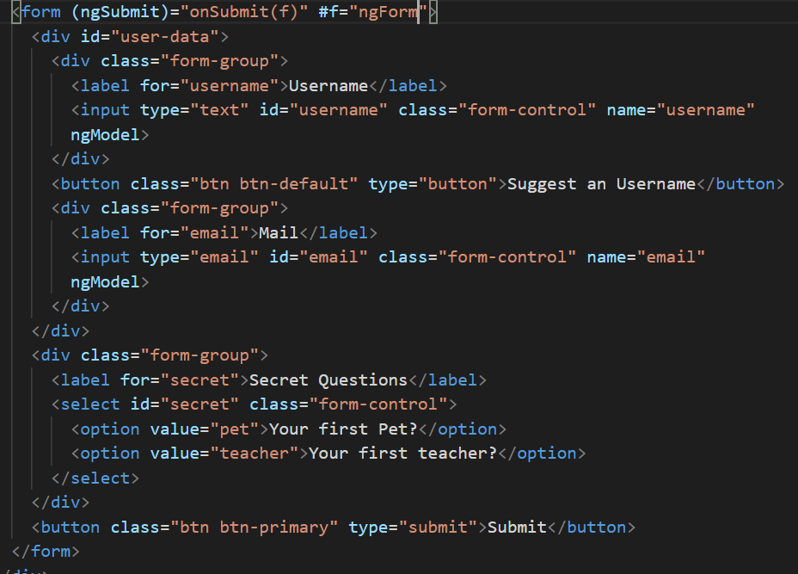

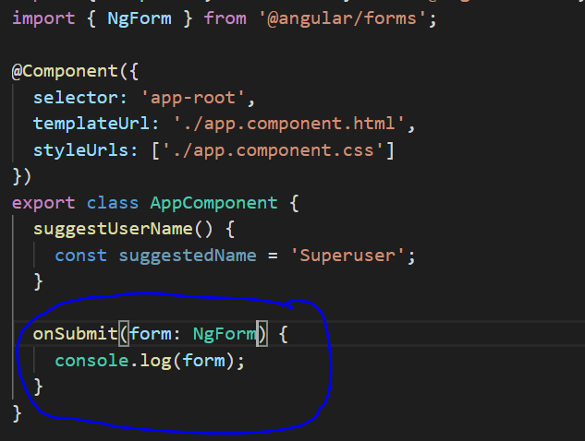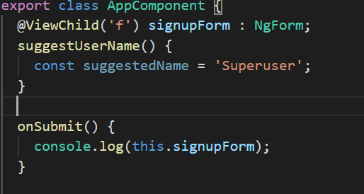

* 1. For the template-driven approach, you need the directives. You can add those directives(**CheckboxRequiredValidator**, **EmailValidator**, **MinLengthValidator**, **MaxLengthValidator**, **PatternValidator**, **RequiredValidator**) into your template.

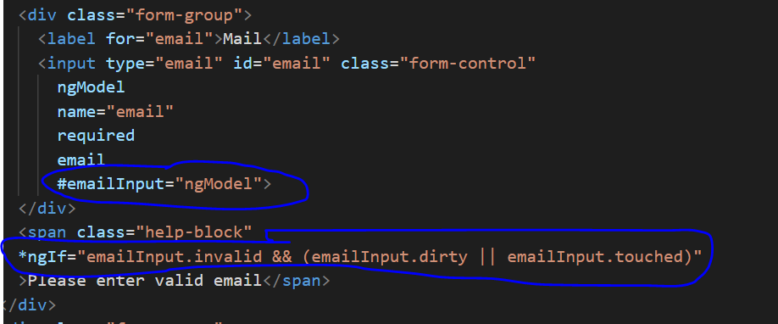

* 1. Set Default Values with ngModel Property Binding in Template-Driven Forms.

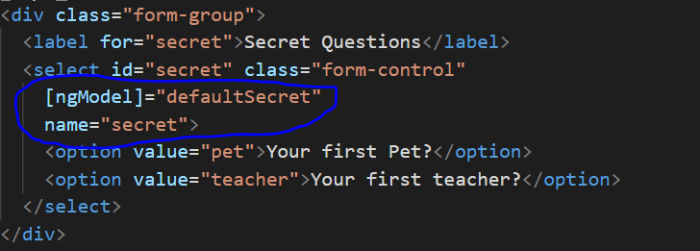

* 1. Grouping Form Controls in Template-Driven Forms

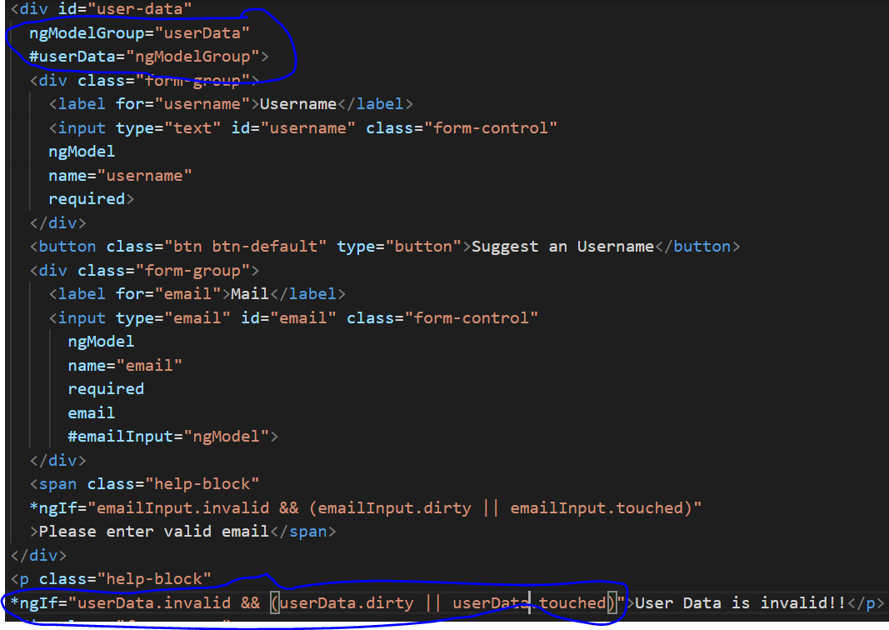

* 1. We can set value to whole form using **setValue()** and for particular form input we can use **patchValue().** And reset() is used to reset form data and status.

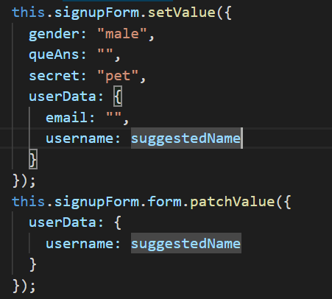

* 1. Angular provides a set of built-in validators that can be used by reactive form controls.

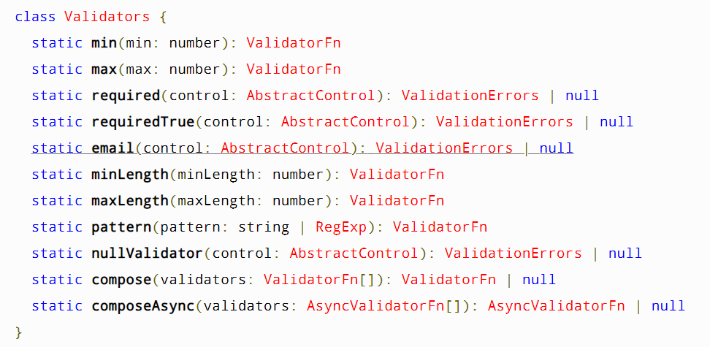

* 1. Additionally, you might also want to enable HTML5 validation (by default, Angular disables it). You can do so by adding the **ngNativeValidate** to a control in your template.

1. Reactive Forms
   1. **FormGroup**, **FormControl**

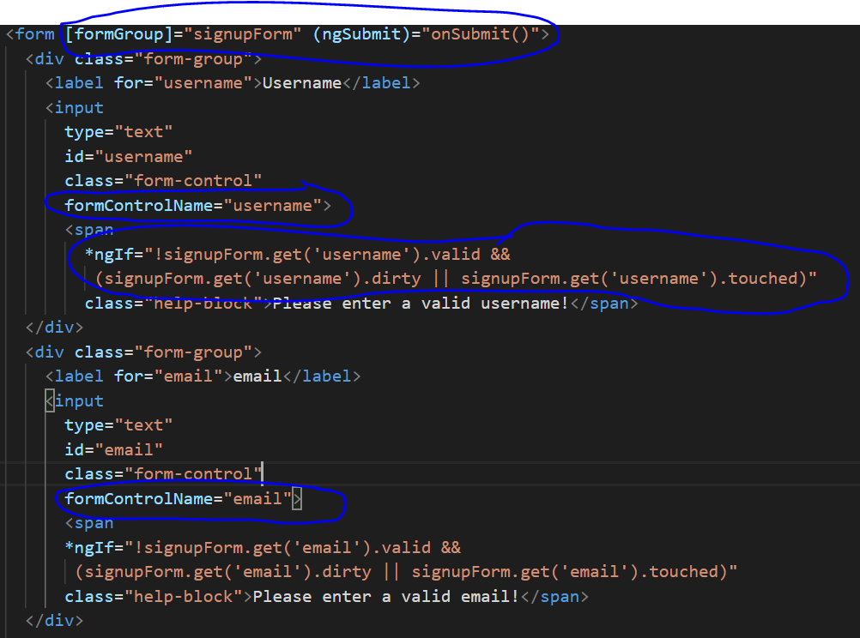

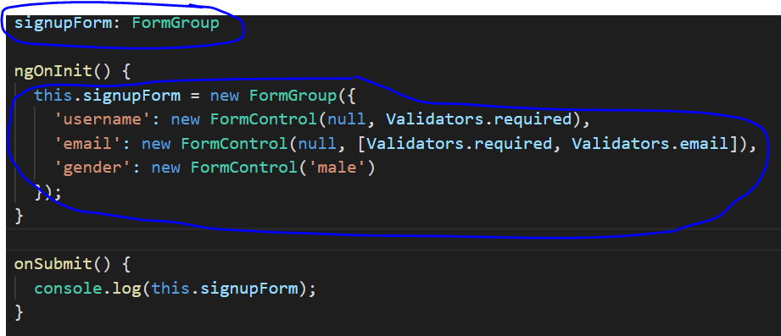

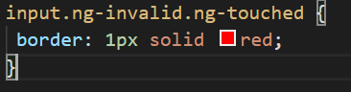

* 1. **FormArray** can be use to add dynamic form control in form group.

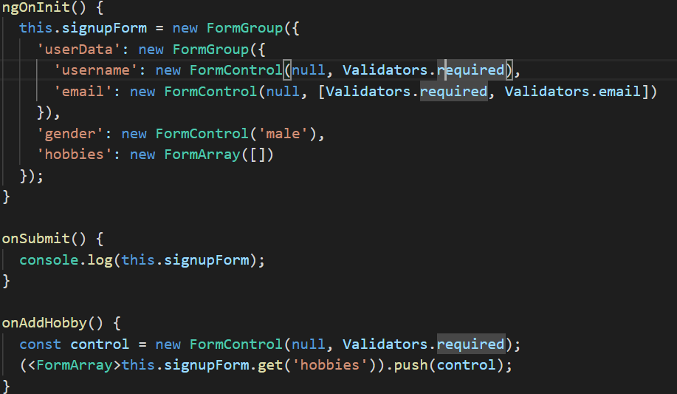

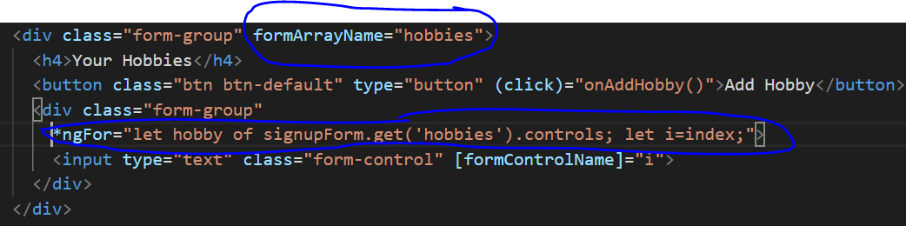

* 1. Creating **Custom Validators** for Reactive Forms

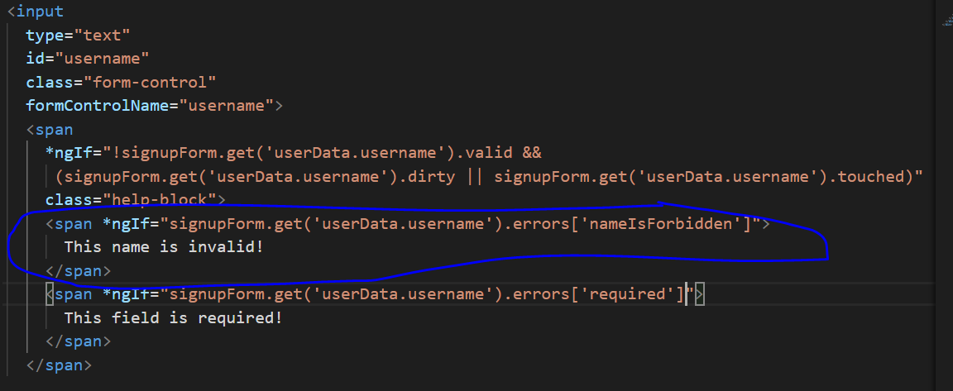

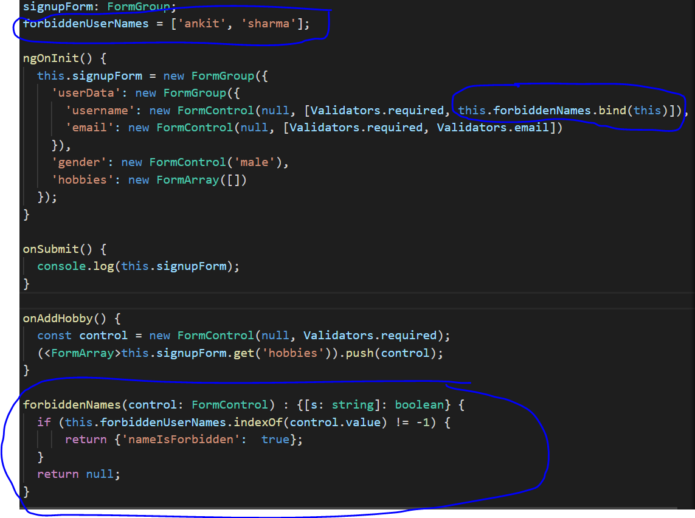

* 1. Creating a **Custom Async Validator** for Reactive Forms. Here status changed from invalid to pending to valid.

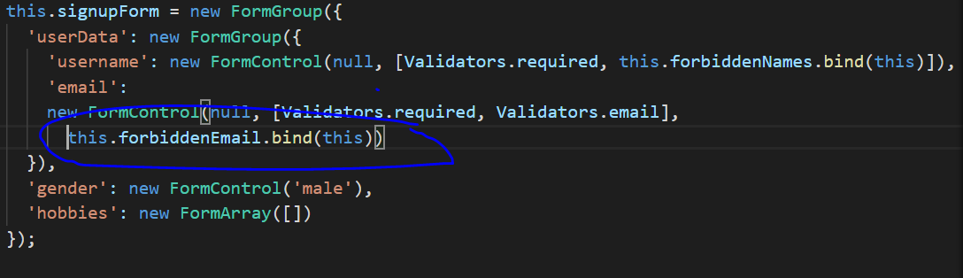

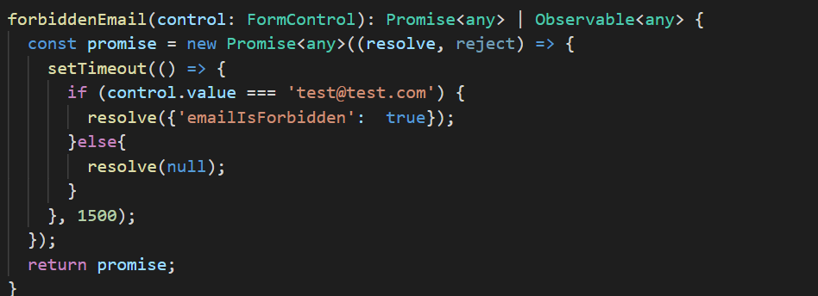

* 1. Reacting to Status or Value Changes

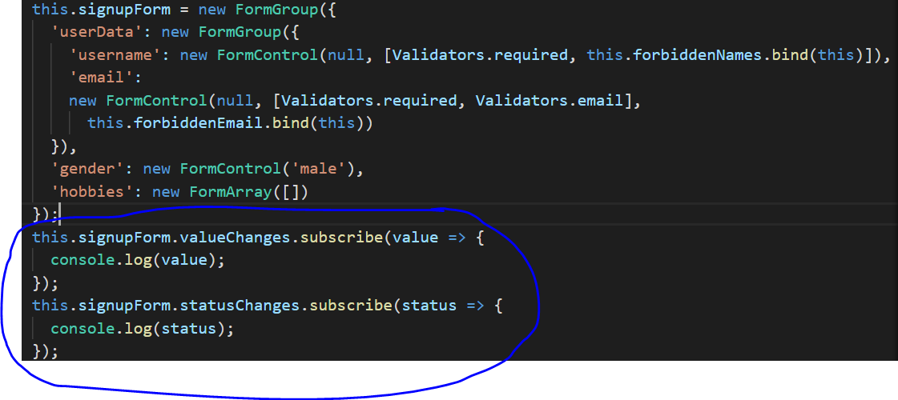

* 1. Setting and Patching Values in Reactive Forms

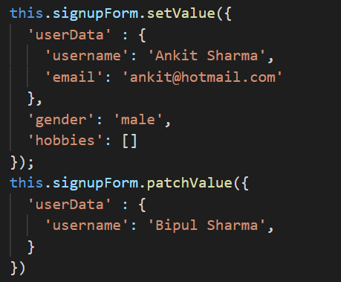

* 1. RemoveAt() and clear() for Form Array

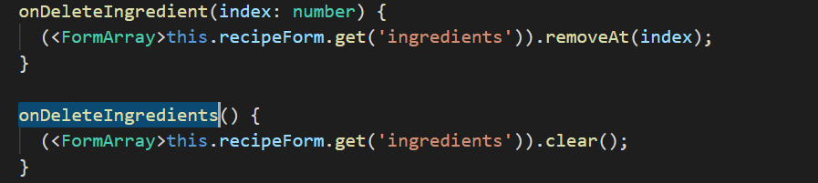

1. Pipes
   1. Pipes are a feature built into Angular 2 which basically allows you to transform output in your template. ng generate pipe pipe-name
   2. Now there are pipes for different types of output and also for **synchronous** and **asynchronous** data.

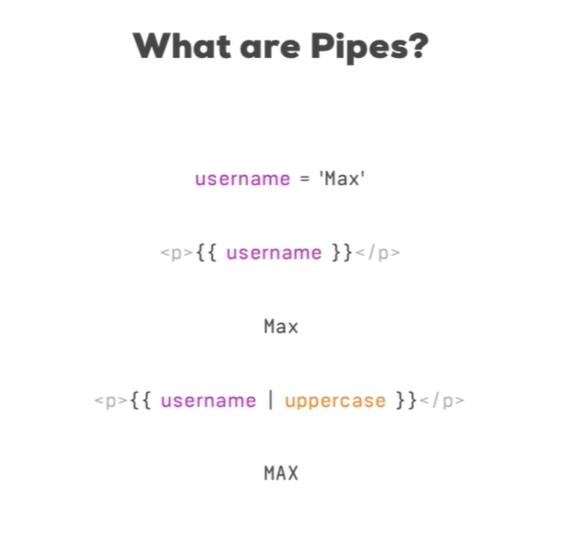

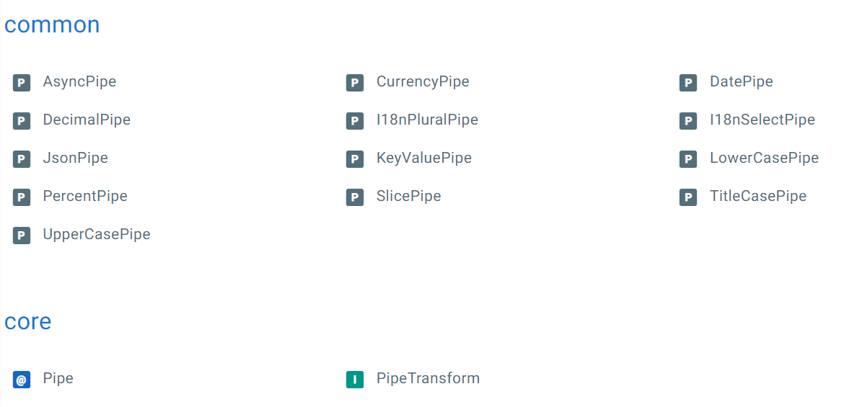

* 1. Chaining Multiple Pipes

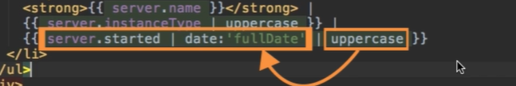

* 1. Create custom pipe

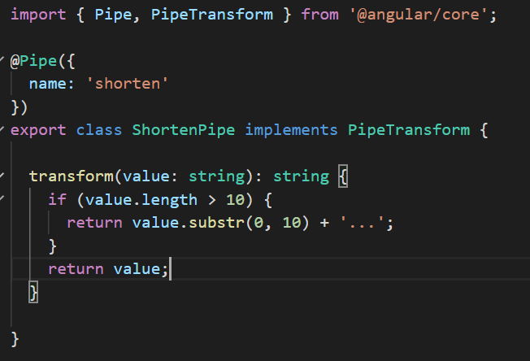

* 1. Parametrizing a Custom Pipe

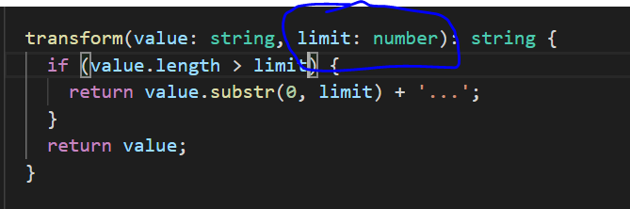

* 1. Filter for looping array

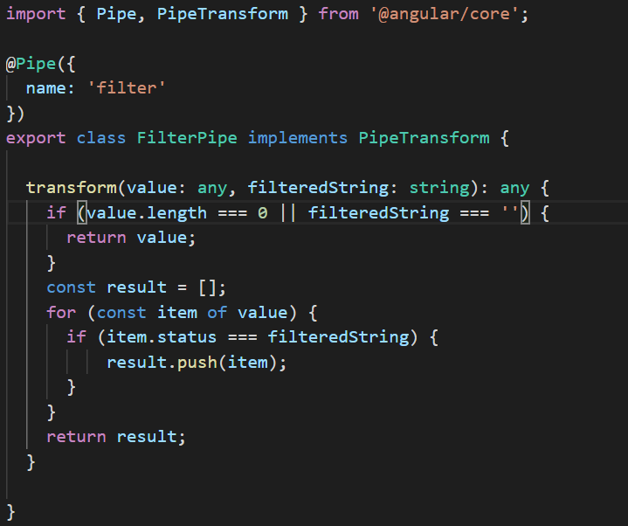

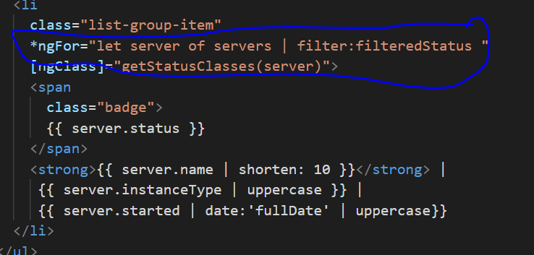

* 1. Pure and Impure Pipes (filter will not work properly if we add some data in array when filter is active)

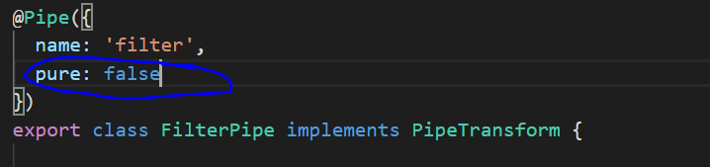

* 1. Understanding the "async" Pipe, this pipe used when we can some data from service o after some time data assigned.

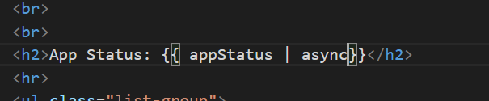

1. Http Client
   1. Browser allow send two request for each http call, one is for checking call is allow or not in that server (Request Method: OPTIONS) and second request will be the http call (Request Method: POST, GET, DELETE, PUT)
   2. Http client request only sent by angular when we subscribe the request because http call return observable always.

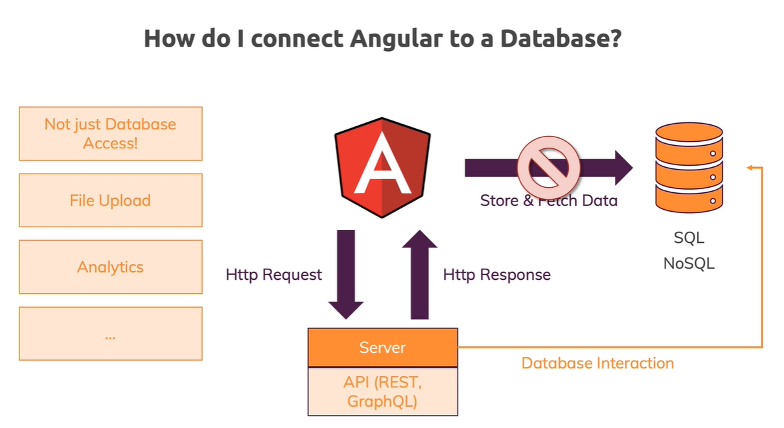

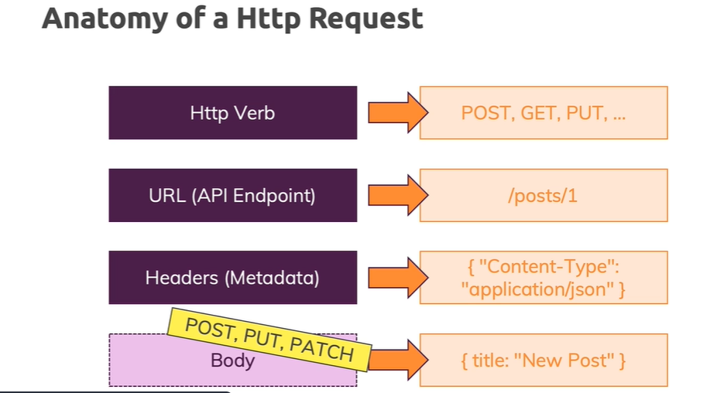

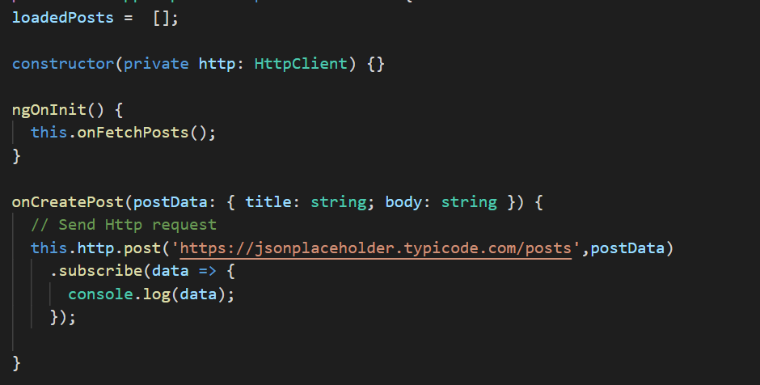

* 1. Before subscribe http request, we can apply **pipe()** to do some operation in response

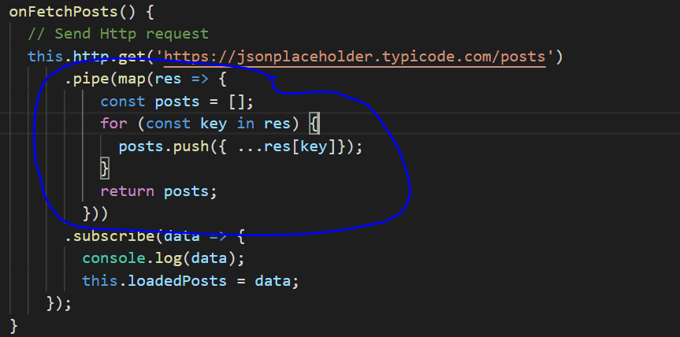

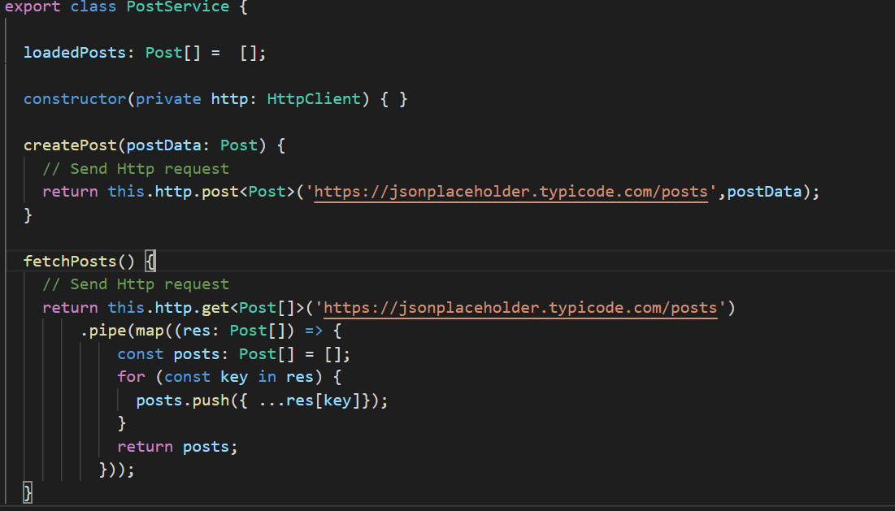

* 1. **Error handling** for http request

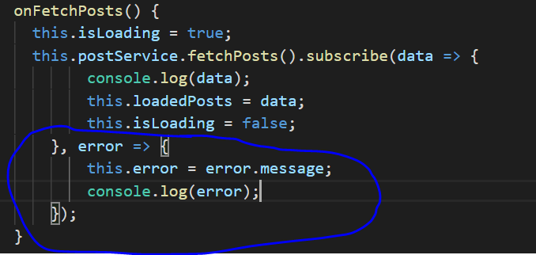

* 1. If we have only one component then we don’t need to subscribe in component instead we can subscribe directly in service. And in this scenario we can use subject for error handling.

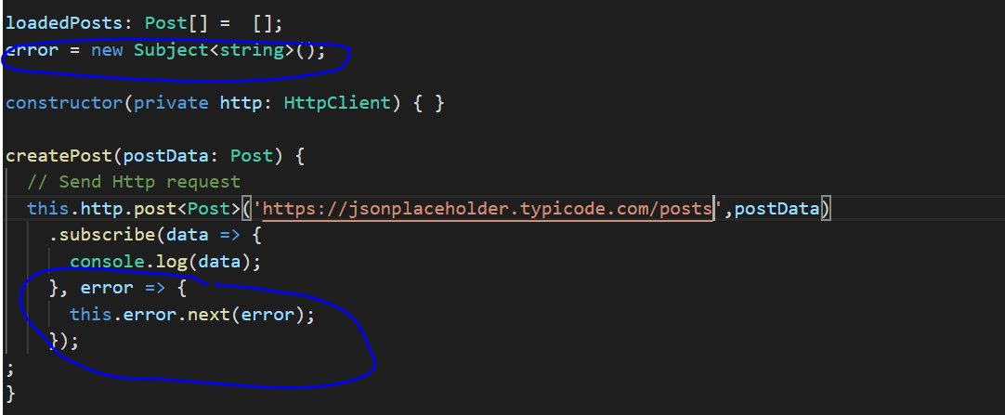

* 1. **catchError** in Rxjs

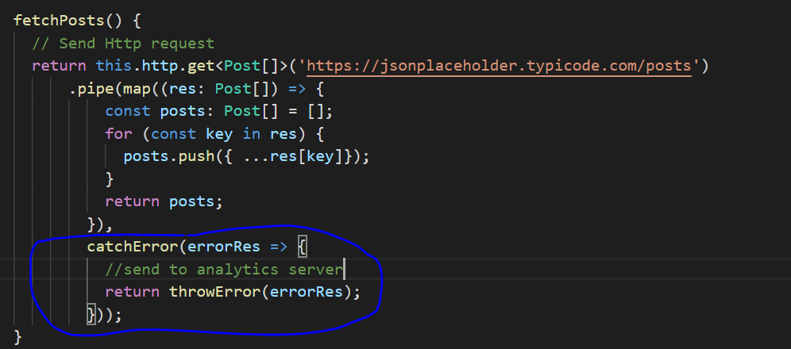

* 1. setting headers

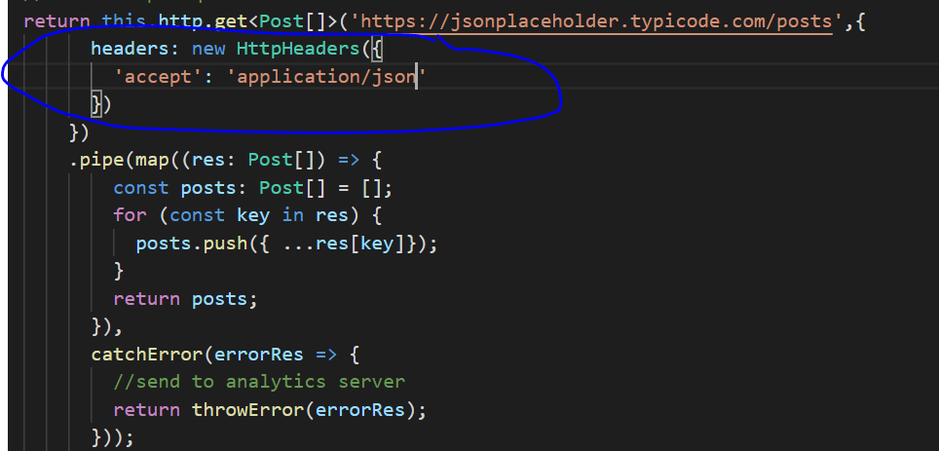

* 1. setting query parameters

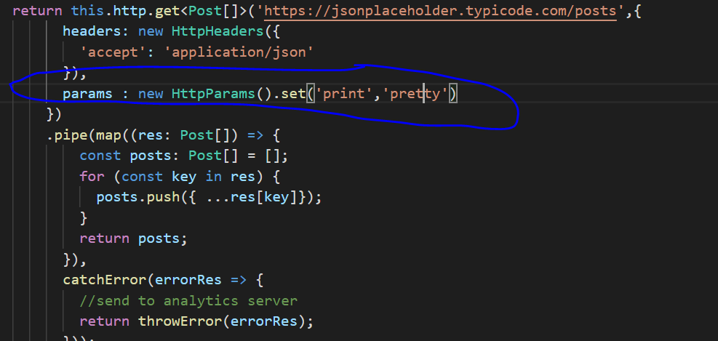

* 1. Observing Different Types of Responses: when we subscribe http request then we will get only body of response so to get whole response we need to pass observe with response value. Type value for observe: 1. body, 2. response, 3. events

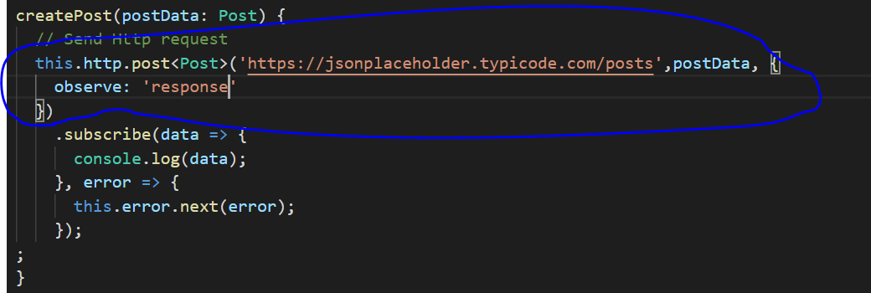

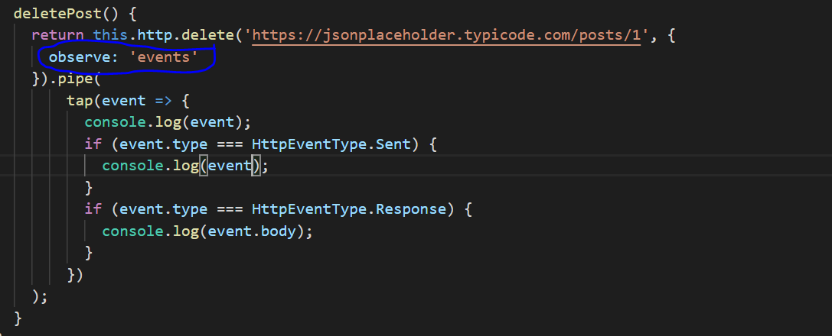

* 1. Changing the Response Body Type: by default value will be json which we can change.(json, text)

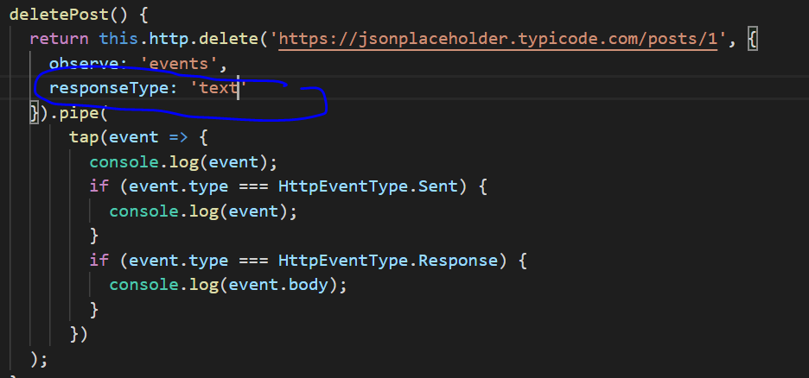

* 1. **Interceptors**: Interceptors allow us to intercept incoming or outgoing HTTP requests using the HttpClient . By intercepting the HTTP request, we can modify or change the value of the request.

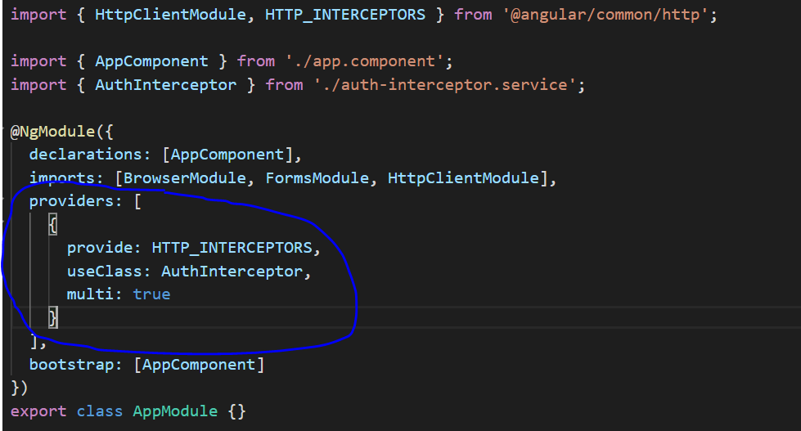

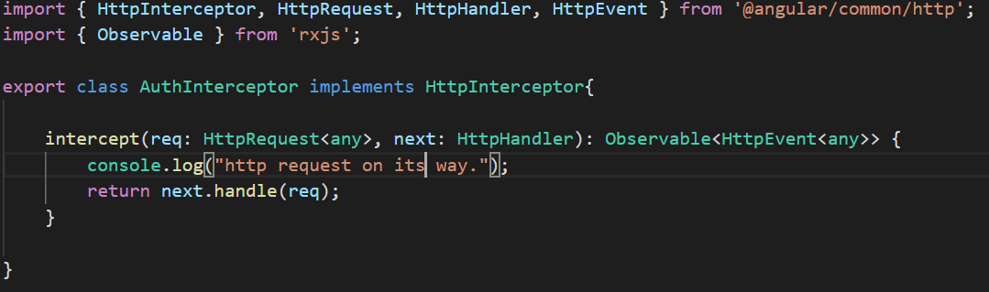

* 1. Modified http request in interceptor

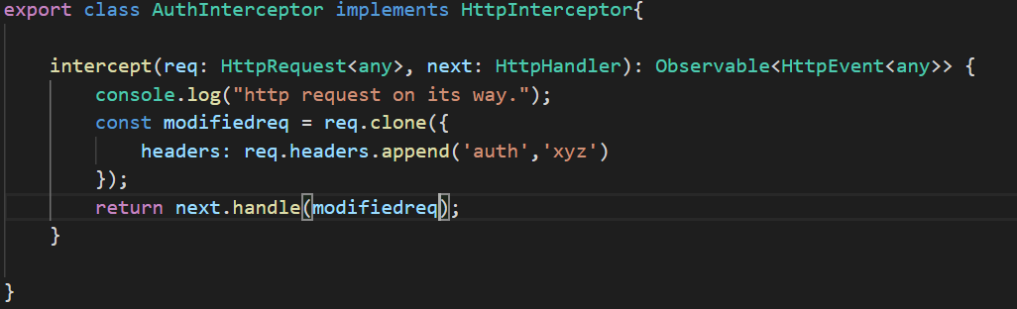

* 1. Response Interceptors

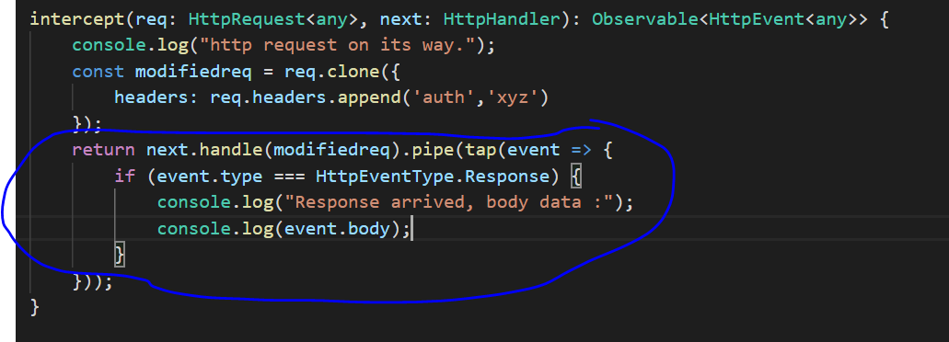

* 1. Multiple Interceptor, which run in order based on order mentioned in AppModule

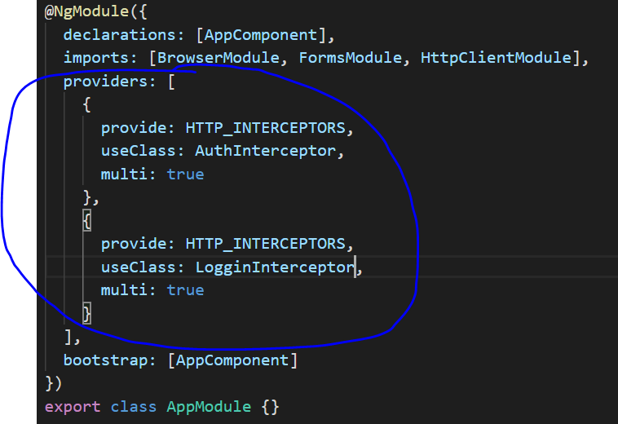

1. Authentication

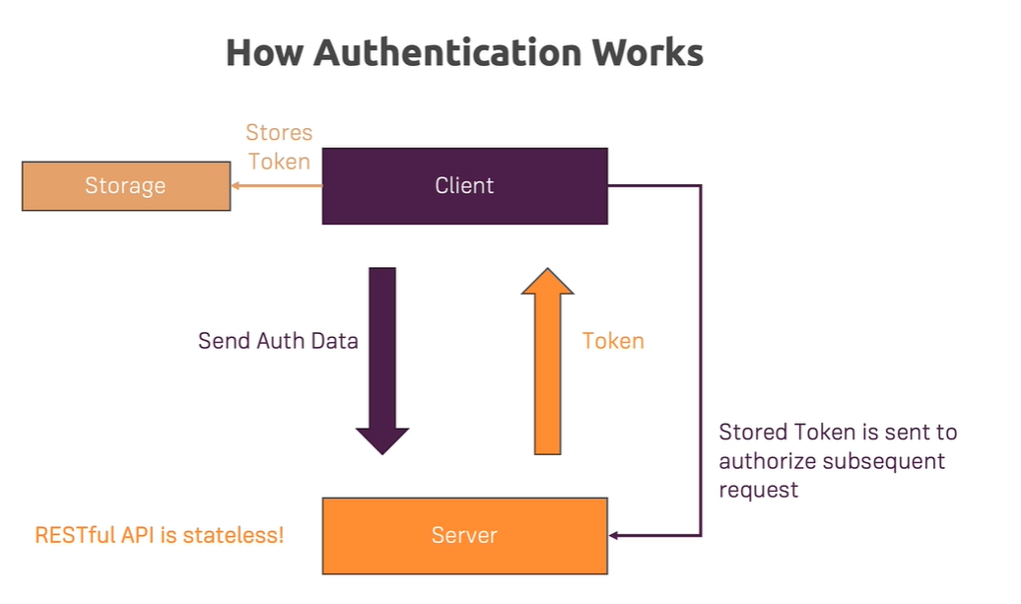

* 1. **Take()** is used when we want to subscribe behavior subject only once and then unsubscribe.
  2. **exhaustMap()** is used when we want to combine two observable and return one observable.

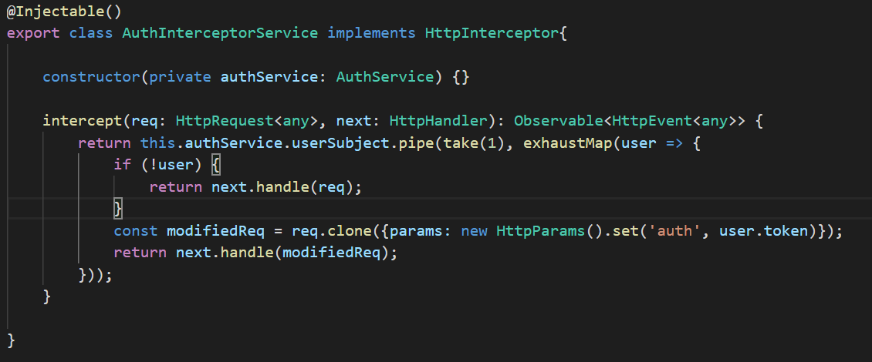

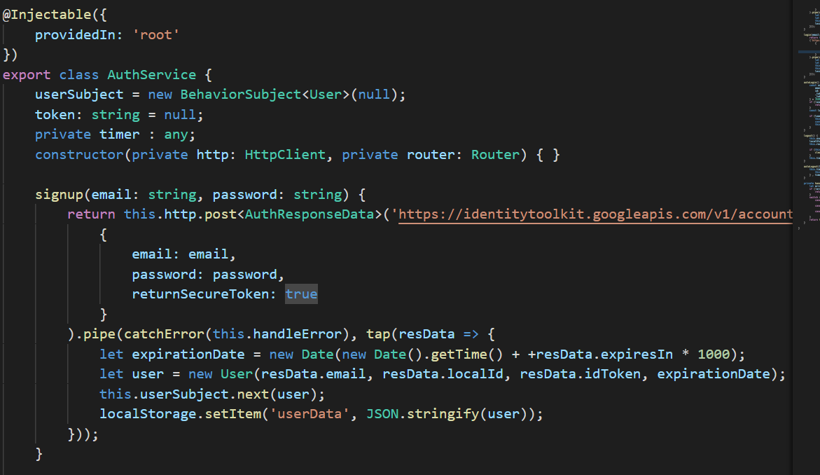

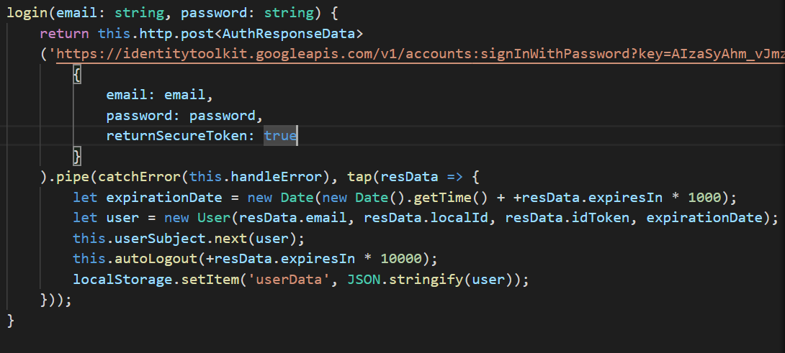

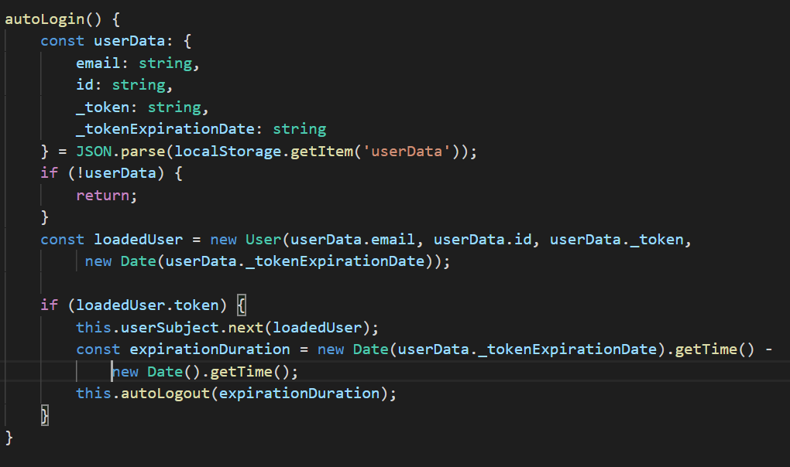

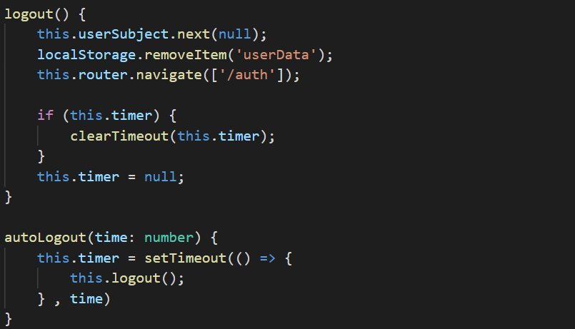

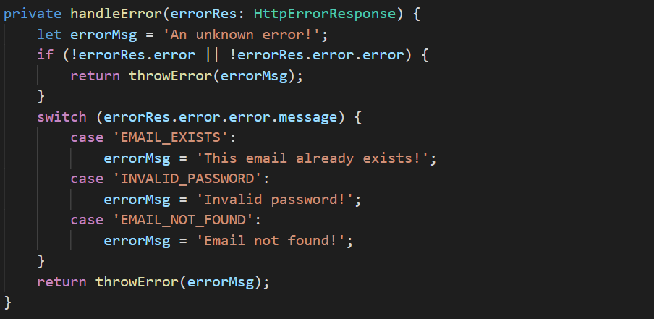

* 1. UrlTree is use to create new routing url tree.

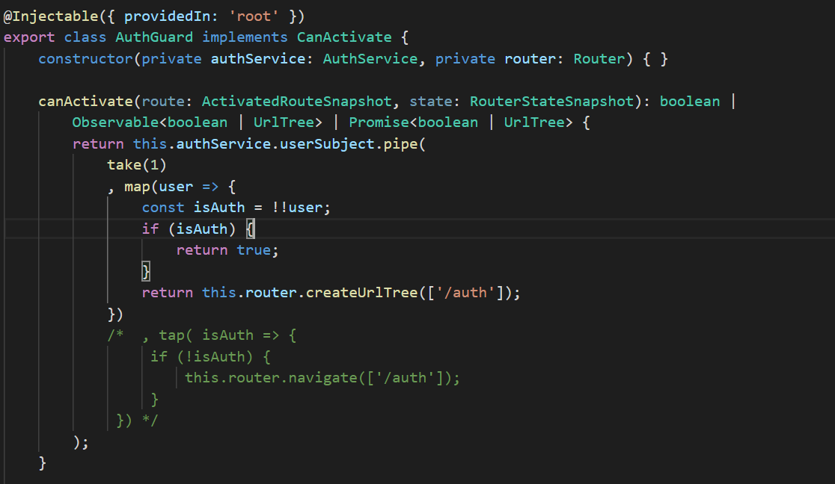

1. Dynamic Components
   1. Create component at run time
   2. **entryComponents** ( < 9+ version) is used to tell angular to create component which is created programmatically (alert, dialog or popup).
   3. Dynamic component created using programmatically then it will not allow data binding (@Input) and event binding(@Output).
   4. https://angular.io/guide/dynamic-component-loader

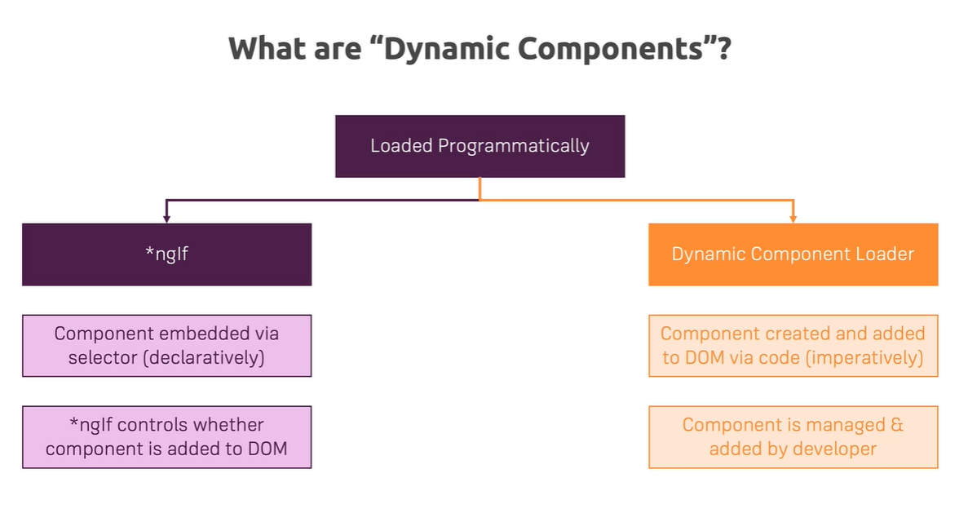

1. Modules & Optimizing Angular Apps

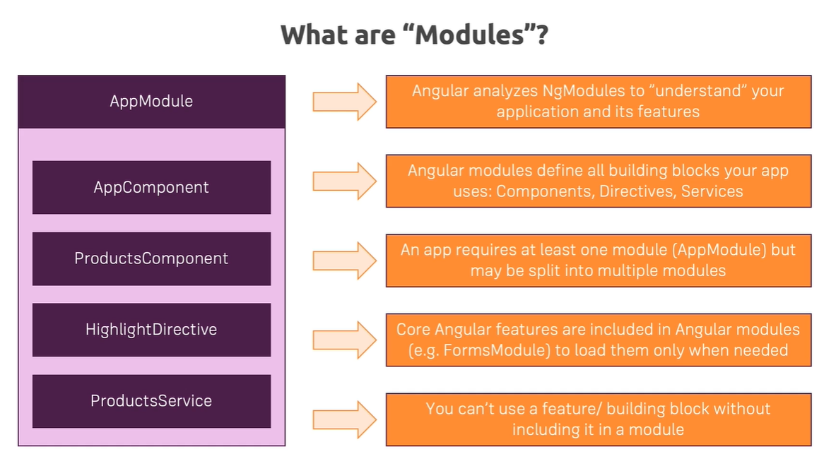

* 1. Create new **Feature Module** and import in AppModule. In this case feature module will not contain the module imported in AppModule so we have to again import in same in Feature module. And Also export all component which declared in feature module if that component is used in AppRoutingModule else no need to export component.

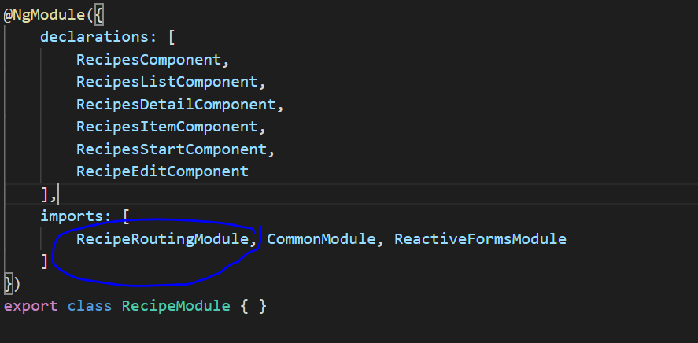

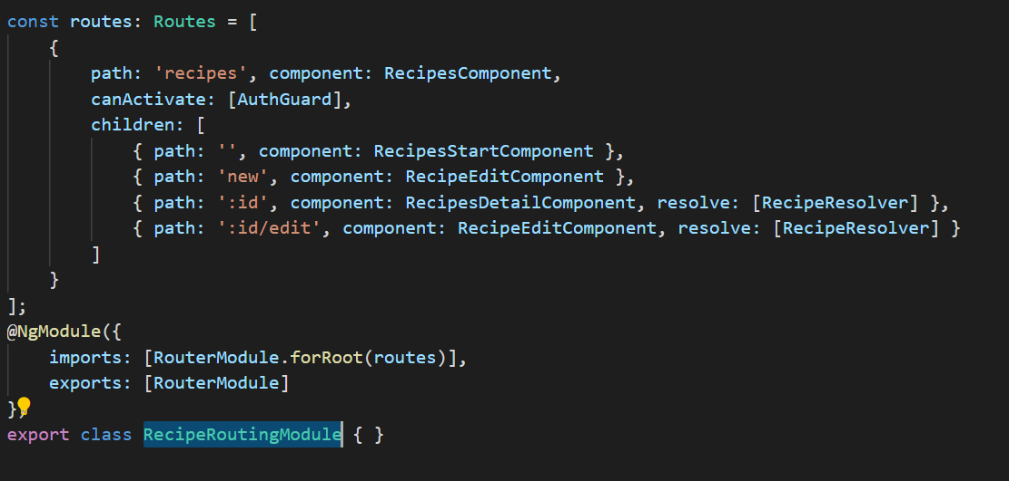

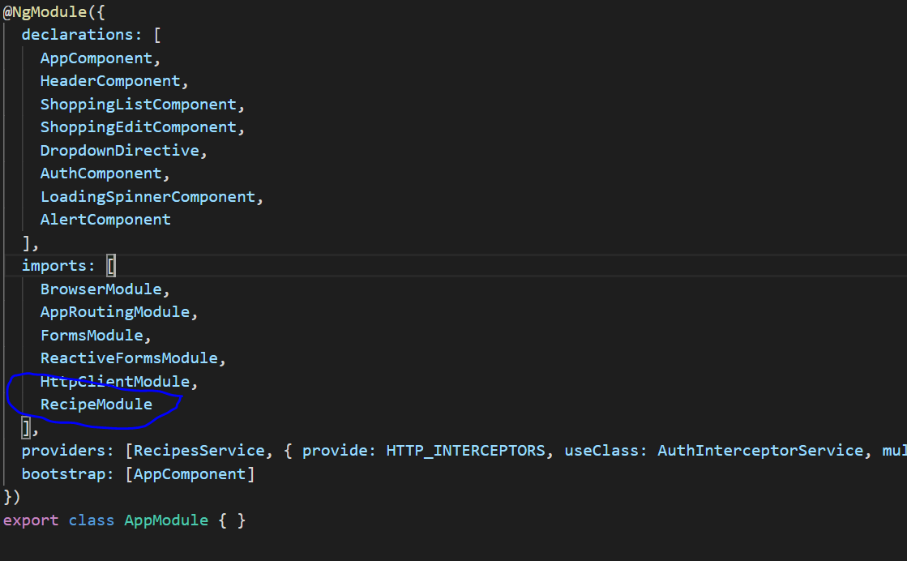

* 1. **Shared Module**: It is used to share component and imported module. If two module import same module then that we can put in shared module and also if we have common component that also we can export from shared module. Import shared module in App Module and Feature Module also.

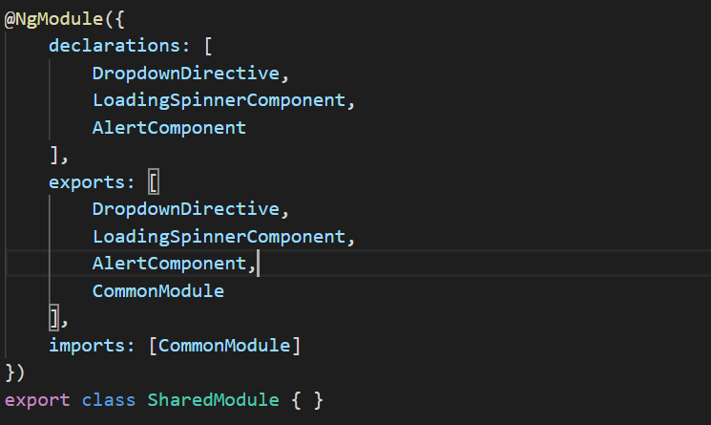

* 1. **Core Module**: It is used to separate all service and Interceptor and import in AppModule.

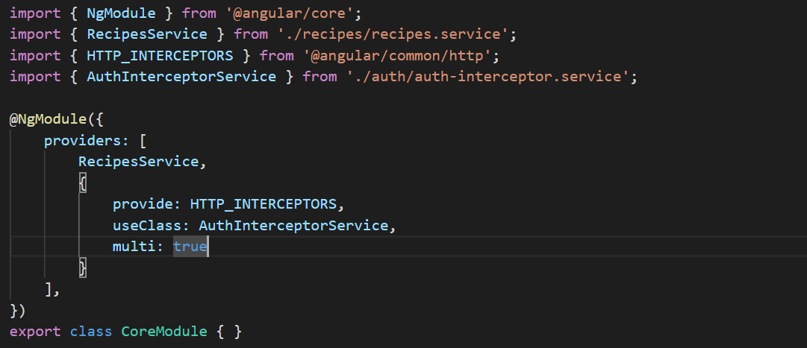

* 1. Lazy Loading: With lazy loading, we initially only load our root route content, so only the app module code and the code of all the components that are registered there and we don't load the other modules like feature module.

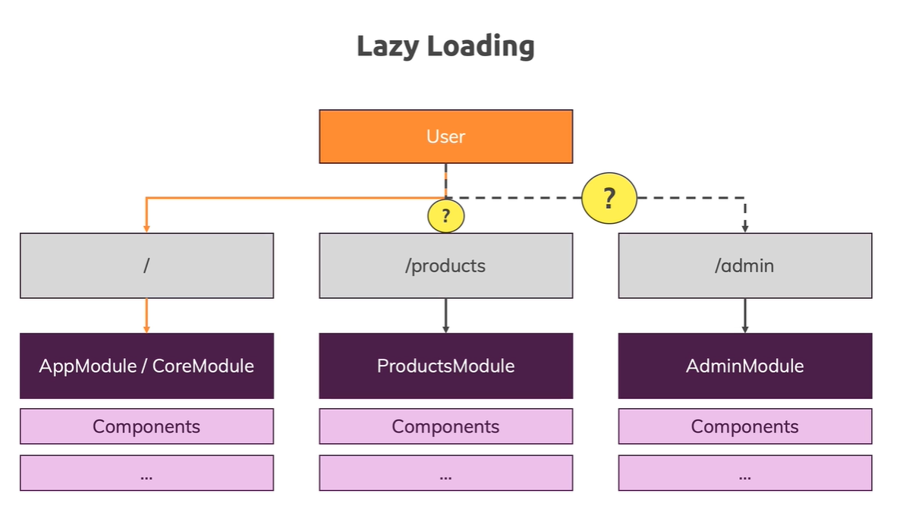

* 1. Remove top child path and use Router.forChild instead of Router.forRoot.

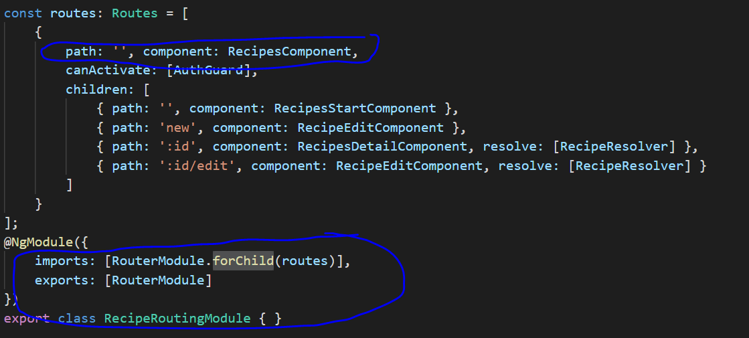

* 1. Old way to do lazy loading

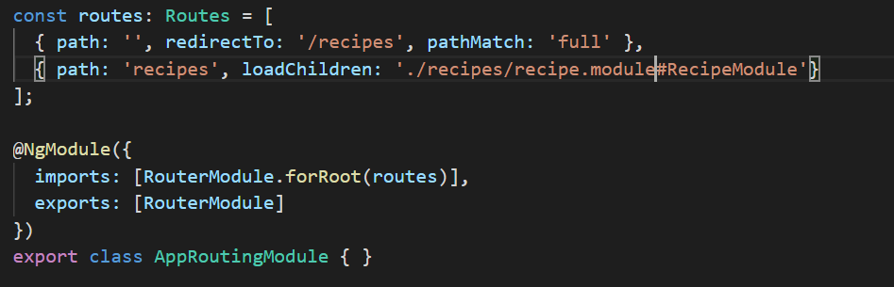

* 1. New way to do lazy loading

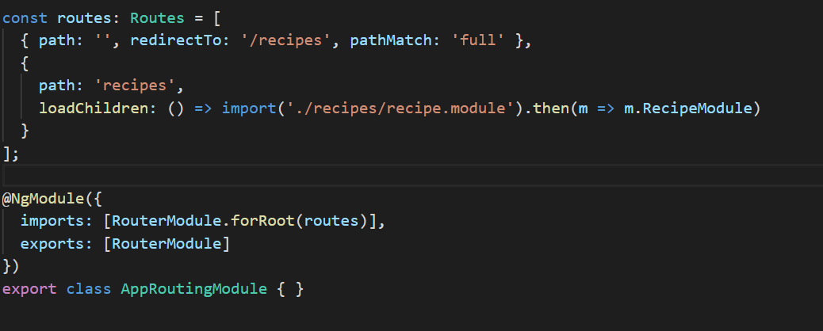

* 1. **Preloading Lazy-Loaded Code**: In lazy loading the feature module will load when we access any route of that module. So that it took time to load that module. To overcome that time we can preloading all feature modules.

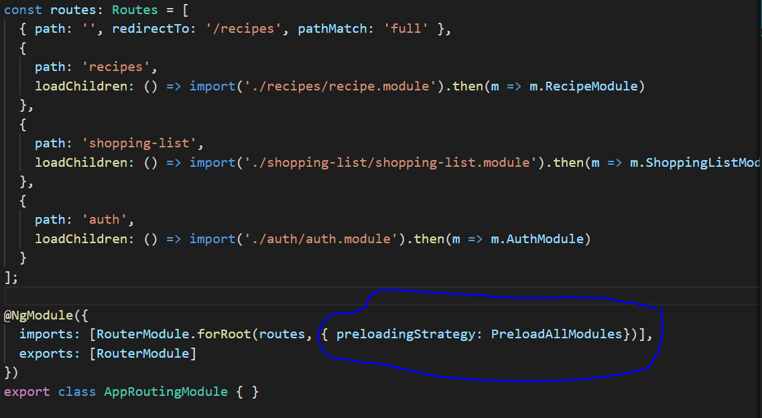

* 1. Service in Lazy Loading

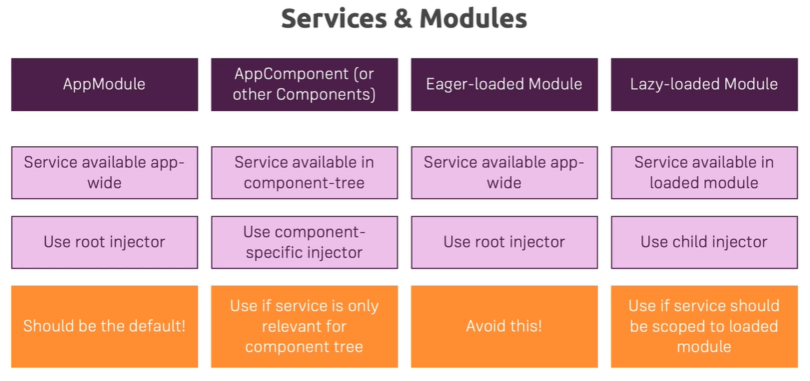

* 1. Ahead-of-Time Compilation vs Just-in-time Compilation: By default its **just-in-time compilation** in development means in ng serve command.

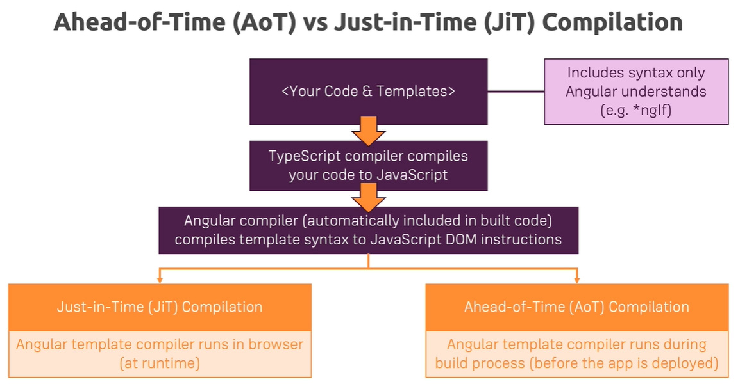

* 1. Command for build angular project by default use **AoT compilation** that’s why bulid file size is very less: **ng build --prod**

1. Deployment

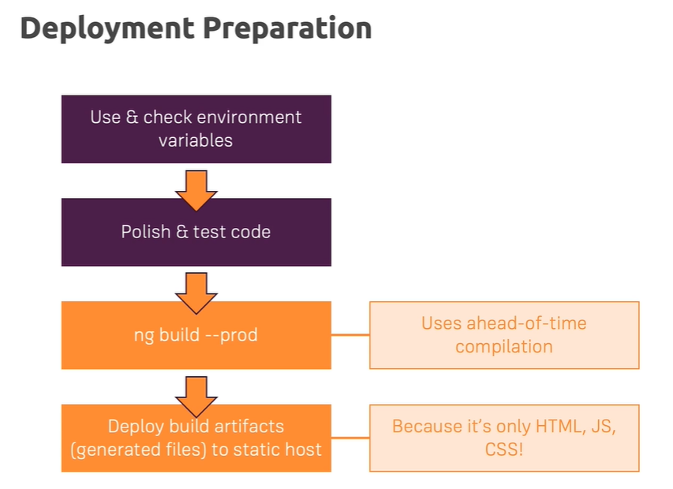

* 1. **Environment variable**

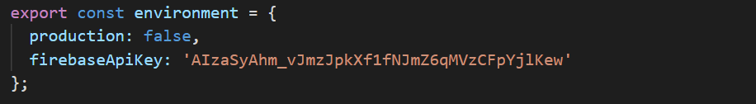



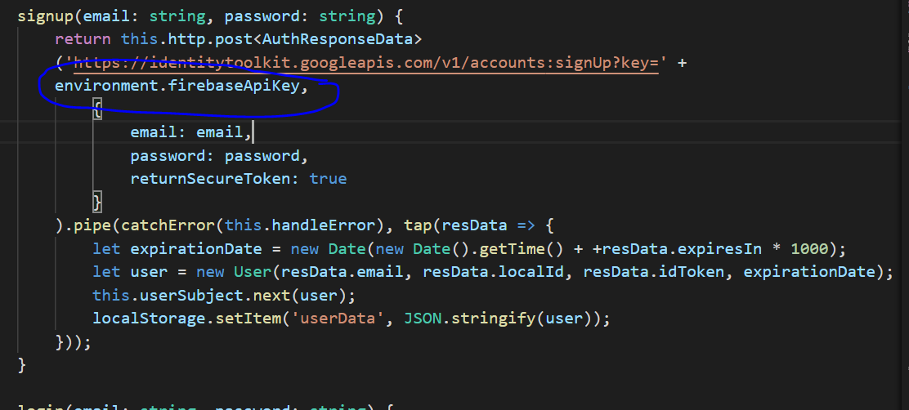

* 1. Deploy in firebase
* Npm install -g firebase
* Firebase login
* Firebase init
* Select project and then Y and the N
* Firebase deploy
* Then access application using url

1. NgRx
   1. **Application state**: in small project we can manage state using component and service and we can store data in backend for persistent. But in big project that will be difficult to manage, we may face issue where we don’t know which component or service is change the state. To solve this issue we can you **ngRx**.

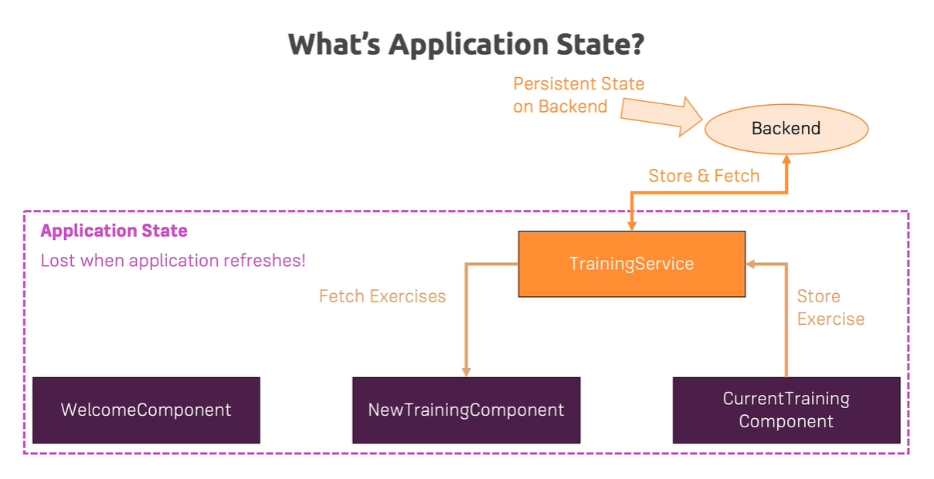

* 1. We also manage state using rxjs but it has also some issue which can be over come by ngRx.

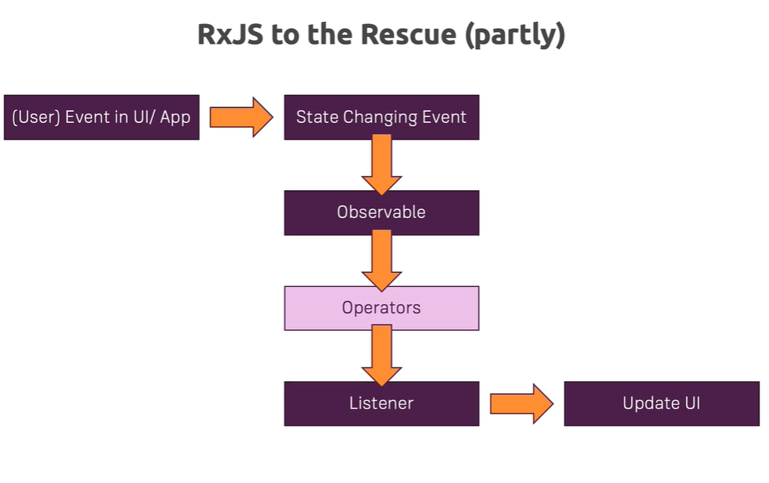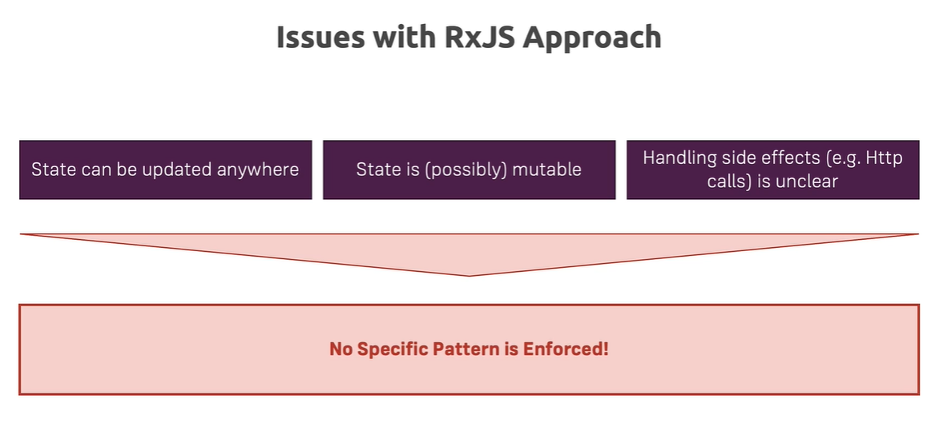

* 1. **NgRx** Store provides reactive state management for Angular apps inspired by **Redux**. Unify the events in your application and derive state using RxJS. We can also we Redux library in place of ngRx but ngRx support lot of angular functionality like observable , uses typescript etc. (https://ngrx.io/docs)

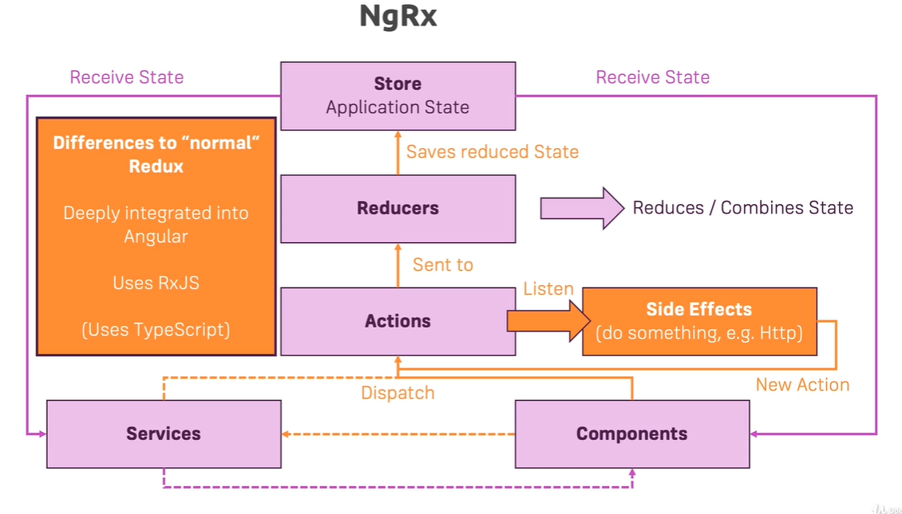

* 1. NgRx managed by angular team, npm install –save @ngrx/store
  2. Reducer is just pure function which perform action on state.

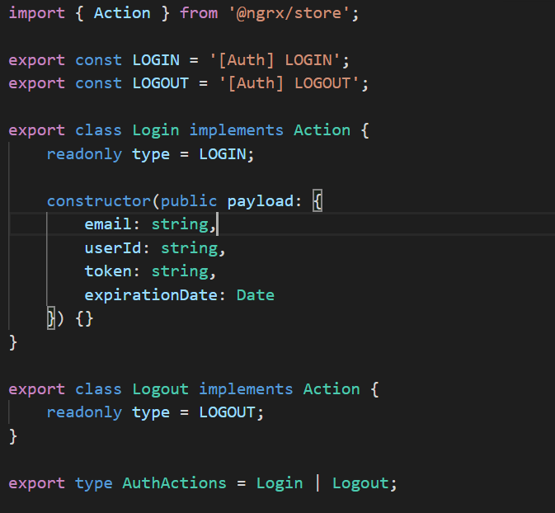

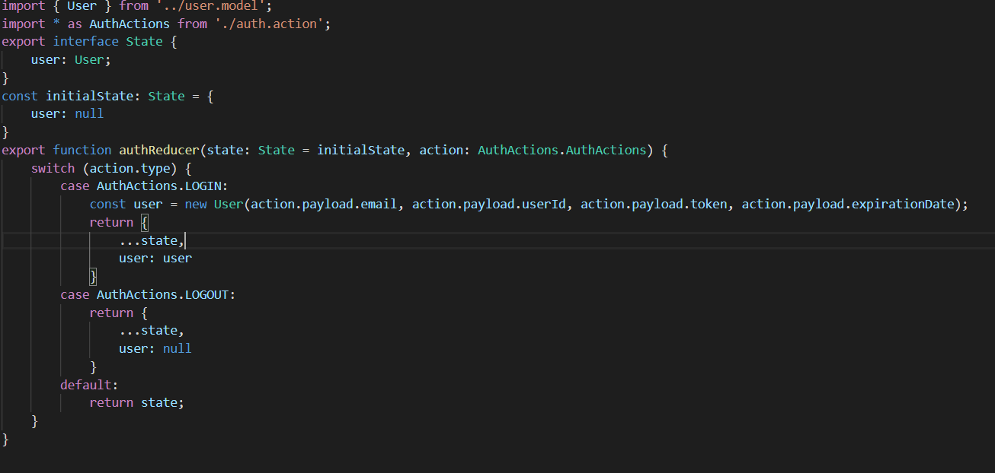

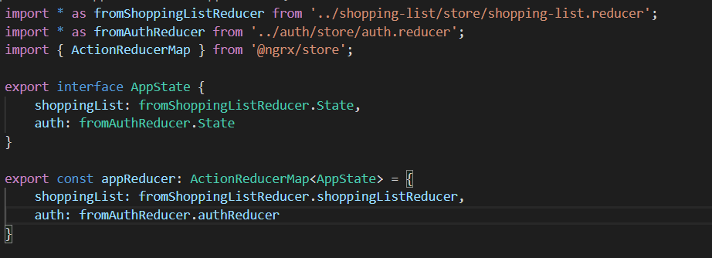

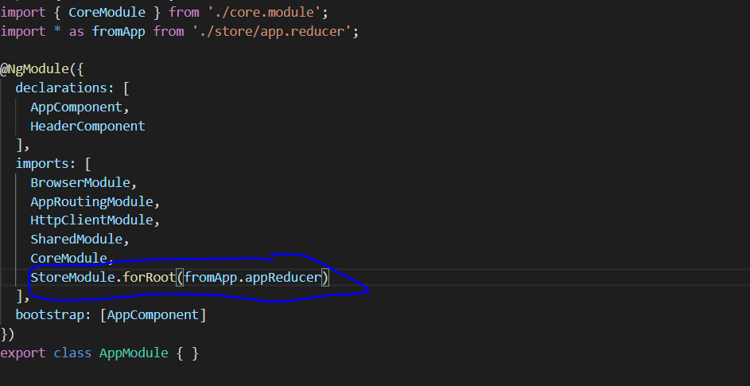

* 1. **NgRx Effects**: npm install –save @ngrx/effects, **Effects** are an RxJS powered side effect model for Store. Effects use streams to provide new sources of actions to reduce state based on external interactions such as network requests, web socket messages and time-based events.
  2. **NgRx Store Devtools**: npm install –save-dev @ngrx/store-devtools, Store Devtools provides developer tools and instrumentation for Store.
  3. **NgRx Router Store:** npm install –save @ngrx/router-store, Bindings to connect the Angular Router with Store. During each router navigation cycle, multiple actions are dispatched that allow you to listen for changes in the router's state. You can then select data from the state of the router to provide additional information to your application.

1. Angular Universal
   1. To install angular universal : ng add @nguniversal/express-engine –clientProject project-name
   2. A normal Angular application executes in the browser, rendering pages in the DOM in response to user actions. **Angular Universal** executes on the server, generating static application pages that later get bootstrapped on the client. This means that the application generally renders more quickly, giving users a chance to view the application layout before it becomes fully interactive.
   3. add ModuleMapLoader to your app.server.ts file - if you're using Angular 9, this is NOT required anymore!
   4. Local storage will not work if we render angular in server side or if we use angular universal. So we can run some code based on platform or project running in browser or in server side.

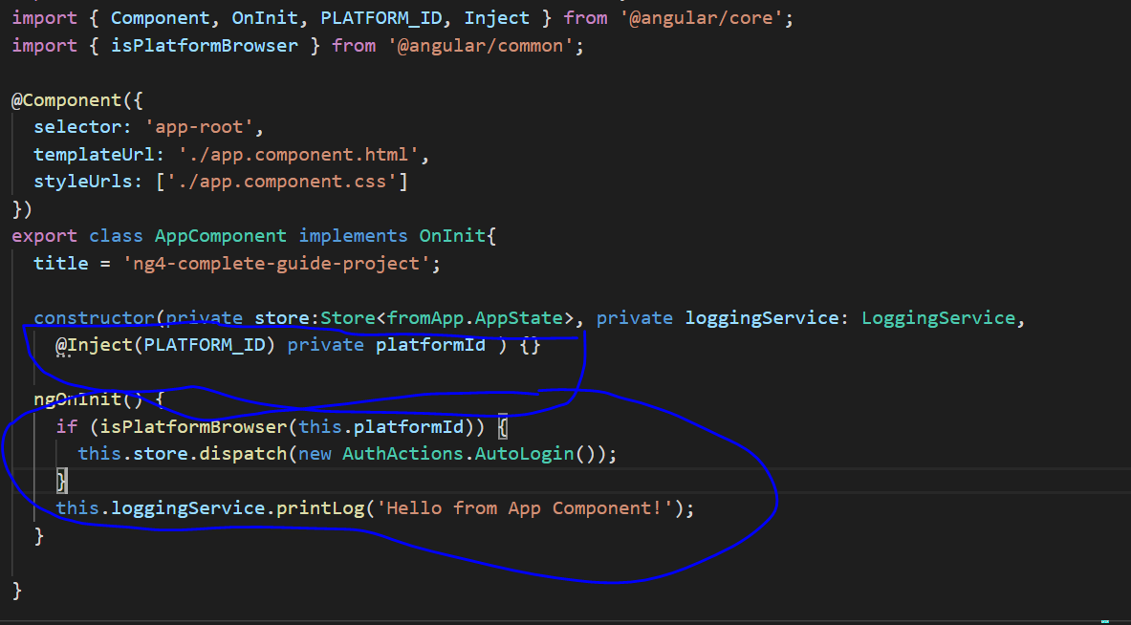

* 1. To run locally in server side use command: npm run dev:ssr
  2. **NestJs**: A progressive Node.js framework for building efficient, reliable and scalable server-side applications. To add nestjs in angular application use command: ng add @nestjs/ng-universal

1. Angular Animations
   1. Making Animations Work with Angular 4+

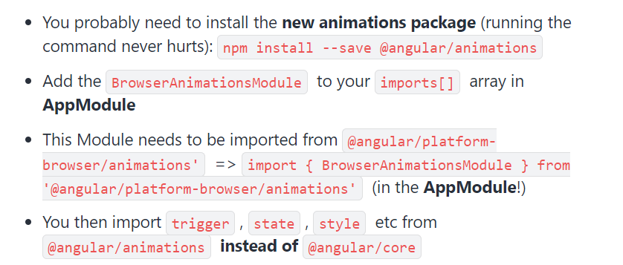

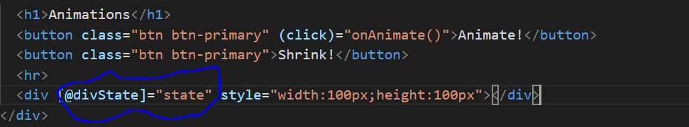

* 1. Trigger(), state() and style()

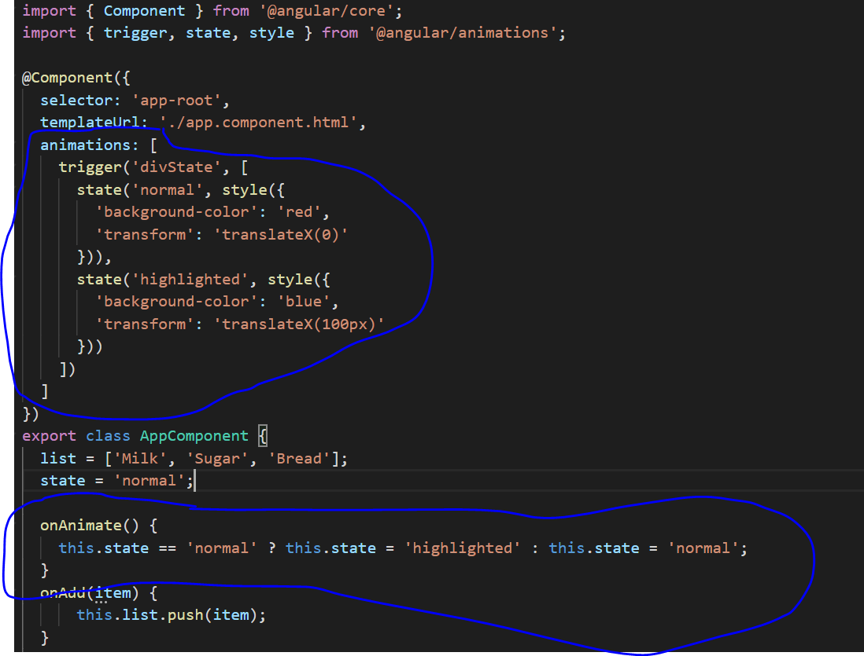

* 1. Transition() and animate()

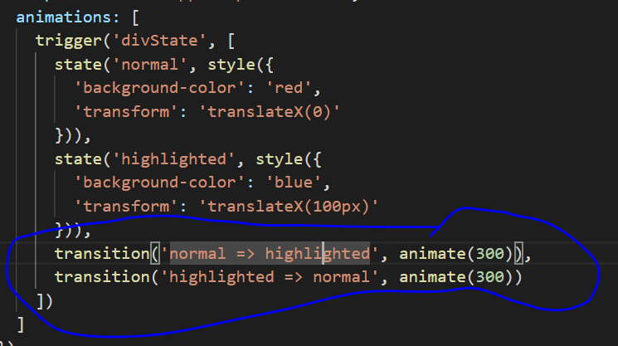

* 1. Two way transition(*)

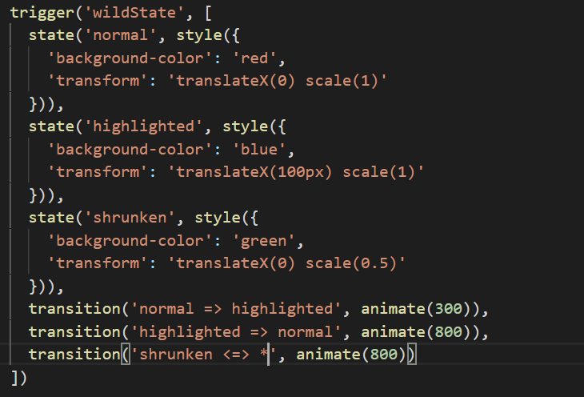

* 1. Void in transition

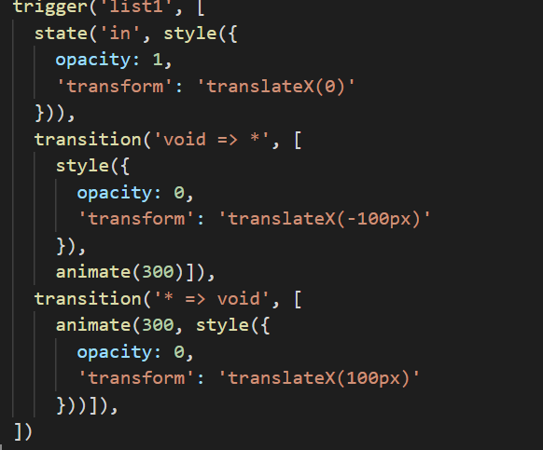

* 1. keyFrames()

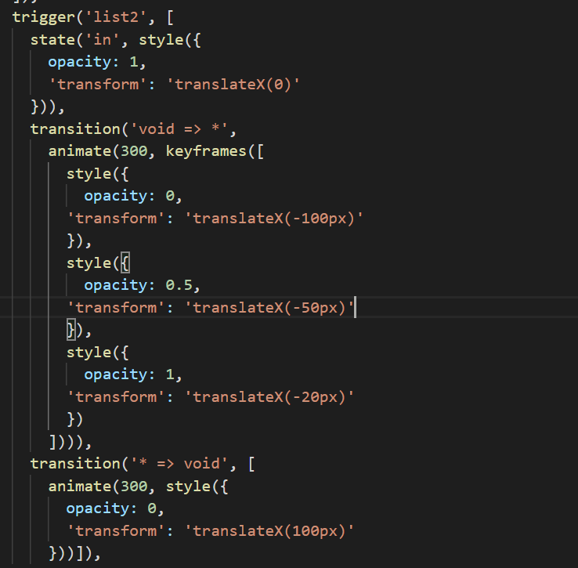

* 1. group() in transition

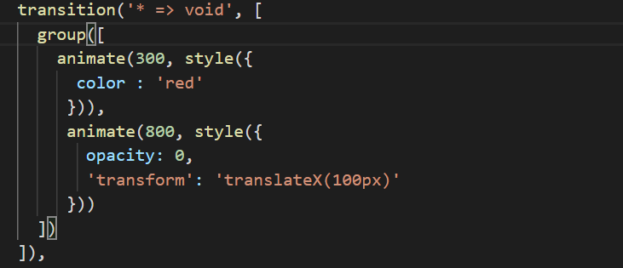

* 1. animations callback function

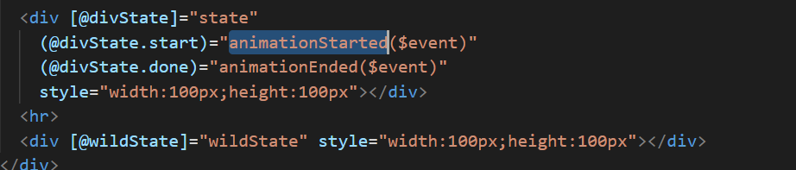

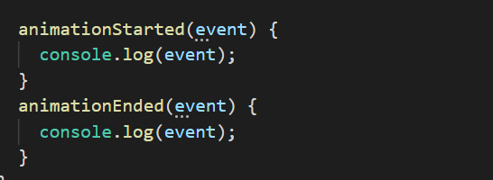

1. Adding Offline Capabilities with Service Workers
   1. if you're fetching the assets off that web page to see is us code the font javascript or also data from an API. The service worker can catch these outgoing requests and do something with them. Like for example cache the responses in a special cache storage or then alter returned these cached responses to your page so that it also works if you've got no internet connection.
   2. To use service worker in angular use command : ng add @angular/pwa
   3. We also need to install http-server( node based server ) to check service worker during development phase :

Npm install -g http-server

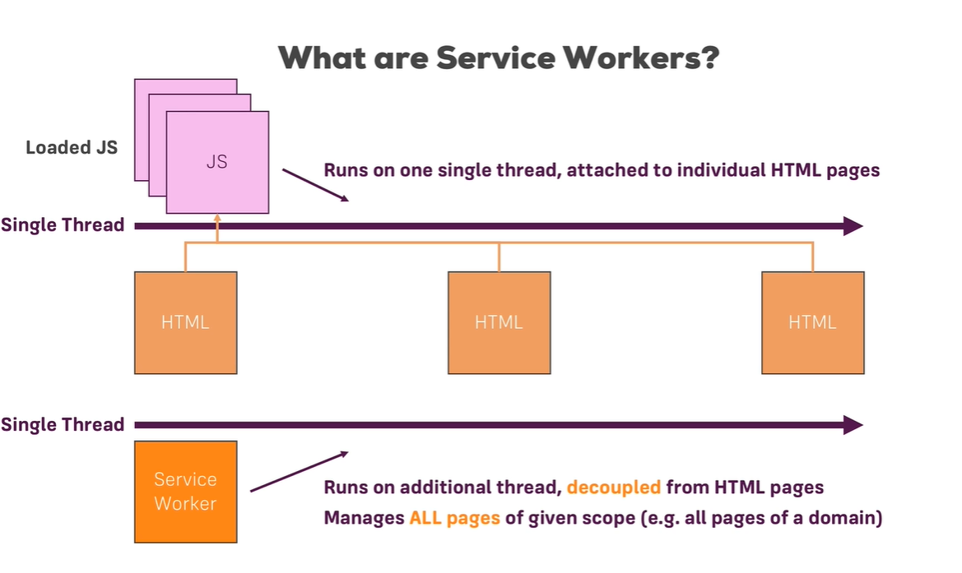

1. Unit Testing in Angular

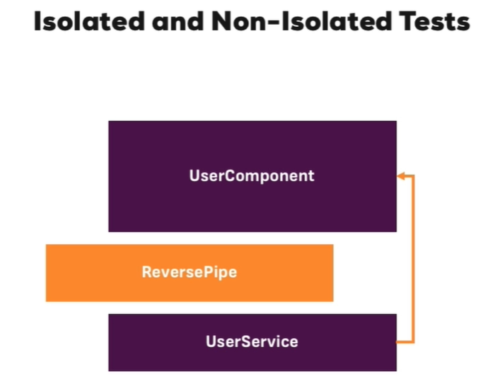

1. Angular as a Platform & Closer Look at the CLI
   1. ng new --help
   2. ng serve –help
   3. ng generate –help
   4. ng lint –help ( use to check code quality or error if have some in project)
   5. ng serve –open (to serve and open in browser)
   6. ng build –help
   7. Angular Schematics:

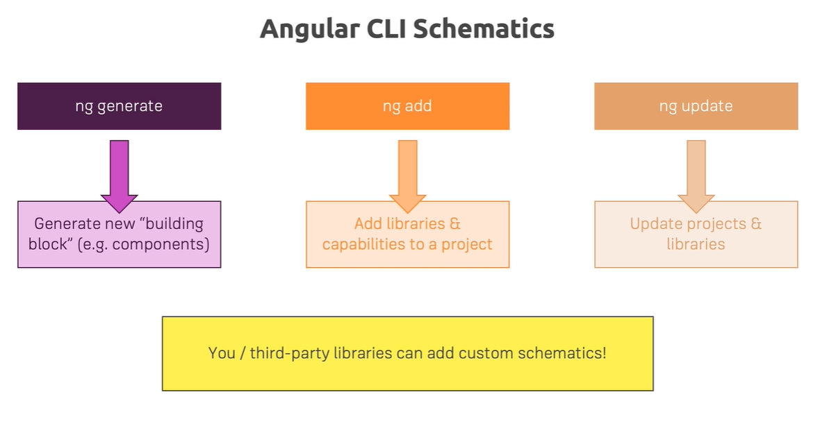

* 1. Angular Material: ng add @angular/material and angular material schematics (<https://material.angular.io/guide/schematics>): ng generate @angular/material:navigation <component-name> and ng update (it will show table with all dependency list which need to update)

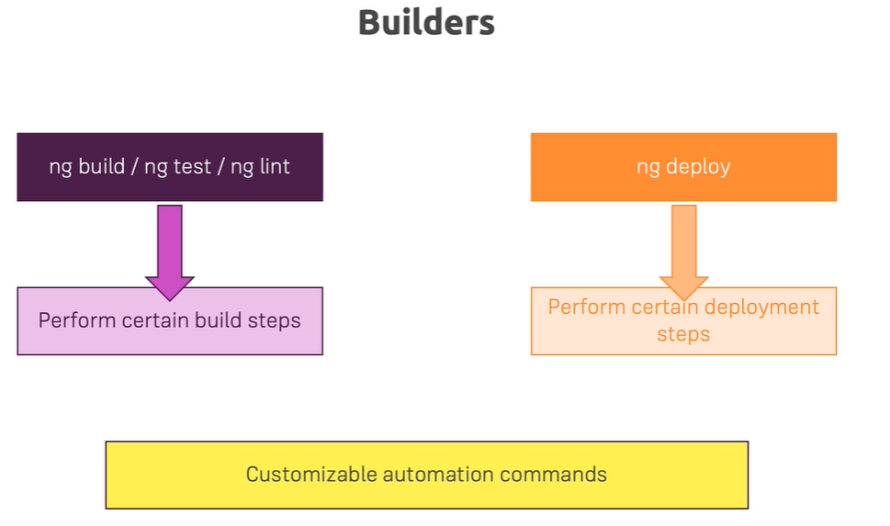

* 1. Builders:

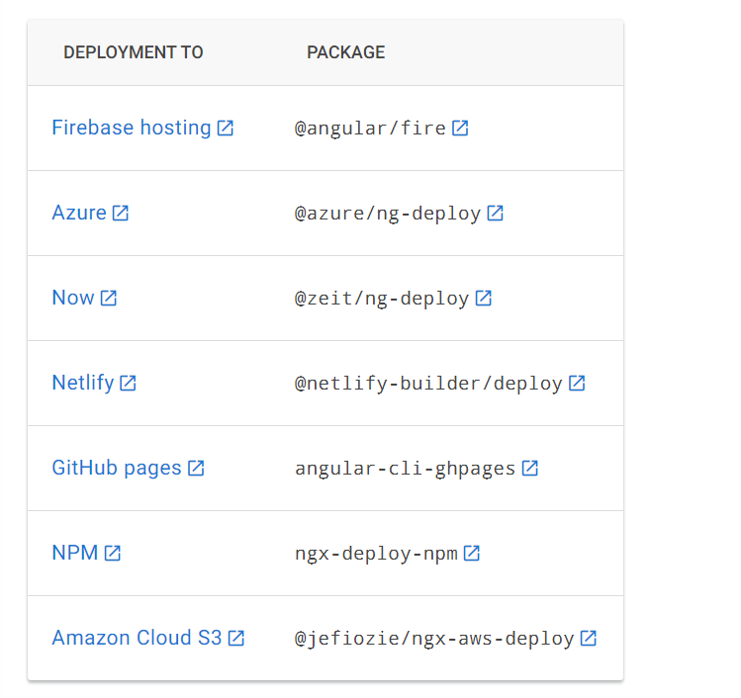

* 1. Different Loading : use browserslist file from angular project

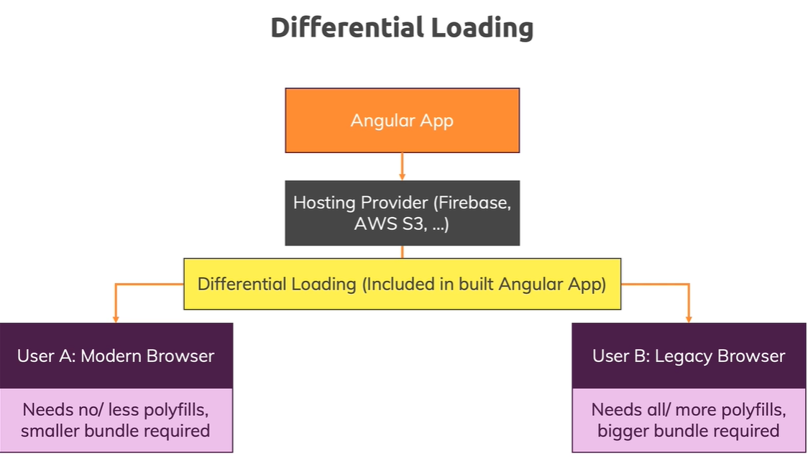

* 1. Multiple Projects : ng generate application and ng new project-name –create-application=false
  2. **Angular Library**: ng generate library my-button (https://angular.io/guide/creating-libraries)

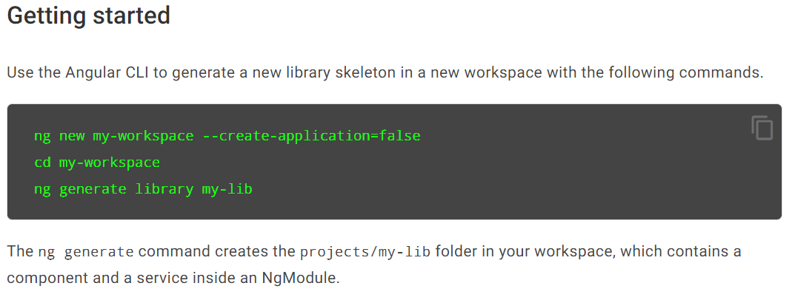

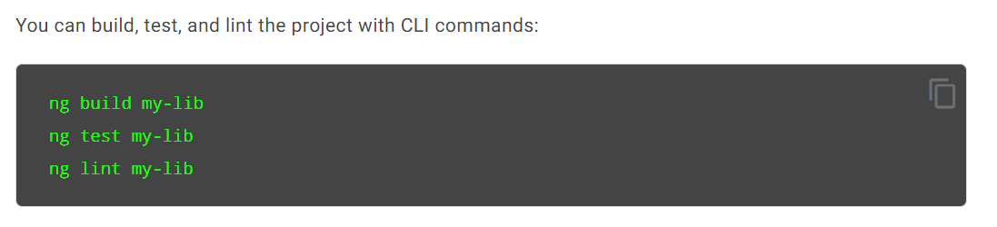

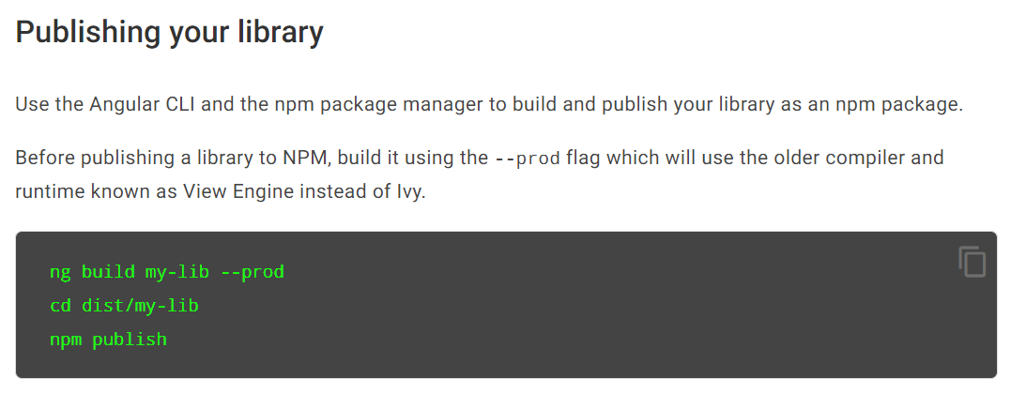

1. Angular Elements
   1. An Angular component packaged as a custom element.( https://angular.io/guide/elements)
   2. It's a feature of the angular framework that allows you to turn your normal angular components which you use in your angular app into native web components
   3. ng add @angular/elements --project=*your_project_name*

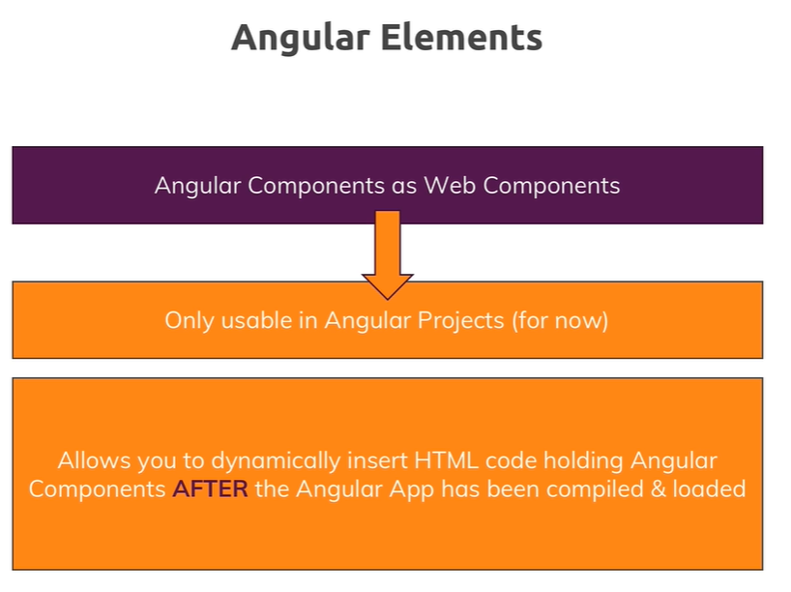

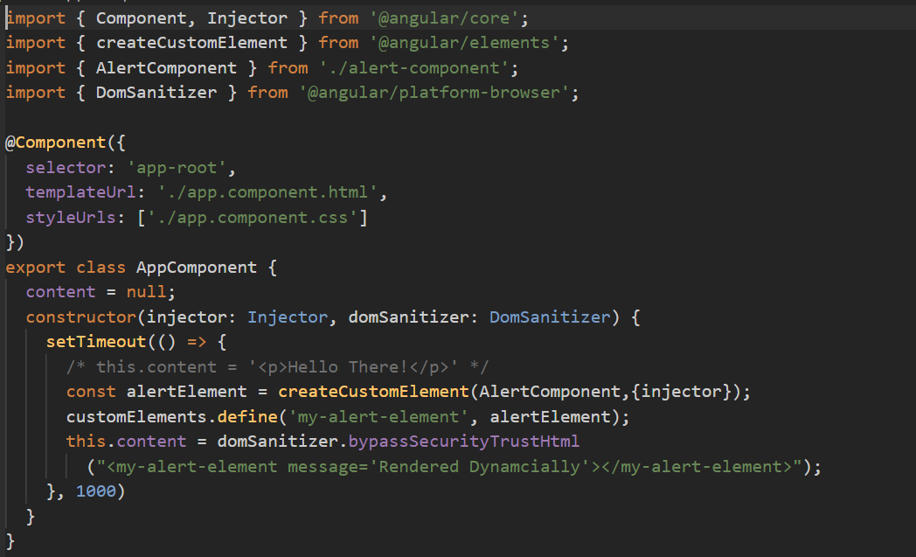

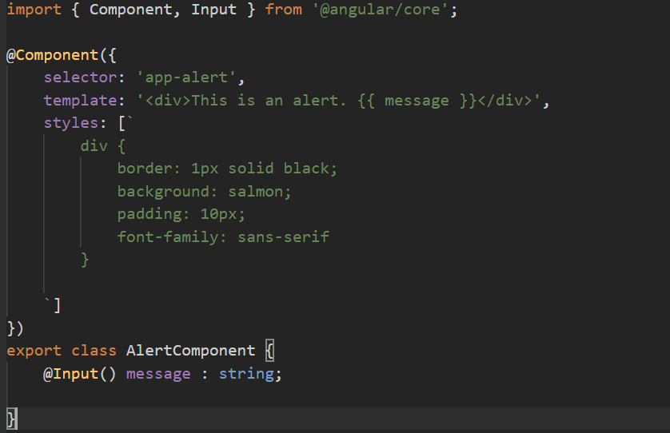

1. Type Script: